UIL State Cross Country Meet ‐ Public Access

Public Parking: Parking and shuttle service will be available on the East Side of Dell Diamond (3550 East Palm Blvd.) for $5 per vehicle.

Admission: Students-­‐$7.00 Adults-­‐ $10.00

Programs, T-­‐Shirts, Concessions: Programs will be available for $5. T-­‐shirts and other items will be available for purchase. Concessions will be available at the course site from 9:00 am – 3:30 pm. Hamburgers, hot dogs, chips, drinks etc. will be available.

Restrooms: Portable toilets will be available to the public and athletes.

Results: Final results will be posted at the meet site. Official results will be posted on the UIL website.

Spectators: Spectators must stay off the course as marked, away from the starting line and finish line, and in roped areas to avoid interfering with any aspect of the race.

No dogs will be allowed into the park.

PUBLIC ENTRANCE (3550 East Palm Blvd.)
(Parents & Guests to park on the East Side of Dell Diamond. Shuttles will be provided from the
parking lot to the course site as there will not be vehicle access into the park.)

- From East (heading westbound) on 79/E Palm Valley Blvd:
  - Turn right onto Tellander Dr.

- From West (heading eastbound) on 79/Palm Valley Blvd:
  - Turn left onto Tellander Dr.
  - Or, continue on to the next intersection and make a u-turn

- From 130 (coming from North) southbound:
  - Take exit 423 toward US-­‐79/Taylor/Round Rock
  - Keep right at the fork and merge onto US-­‐79 S/E Palm Valley Blvd
  - After approximately 3.1 miles, turn right onto Tellander Dr.

- From 130 (coming from South) northbound:
  - Take exit 423 US-­‐79 S/E Palm Valley Blvd
  - Keep left at the fork, follow signs for US-­‐79 S and merge onto US-­‐79 S/E Palm Valley Blvd
  - After approx. 3.1 miles, turn right onto Tellander Dr.

- From I-­‐35 (coming from North) southbound:
  - Take exit 253A toward US-­‐79/Hutto/Taylor & merge onto the frontage rd
  - Turn left onto Cty Rd 175/W Palm Valley Blvd/Sam Bass Rd
  - Turn left onto Tellander Dr.

- From I-­‐35 (coming from South) northbound:
  - Take exit 253 toward Sam Bass Rd & merge onto the frontage road
  - Turn right onto W Palm Valley Blvd
  - Turn left onto Tellander Dr.
Spectator Parking (Dell Diamond) New For 2019
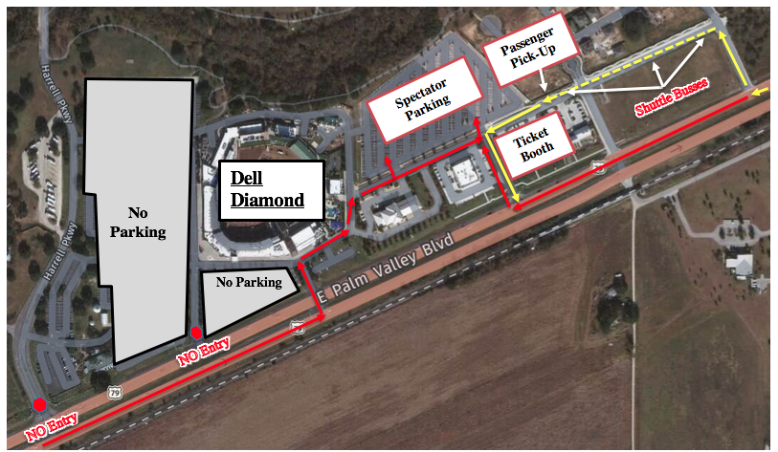

- The spectator parking structure has changed for the 2019 State Cross Country Meet
- Spectators will not have access to park on the East Side of Dell Diamond (3550 East Palm Blvd.)
- Shuttle buses will run continuously to drop-off and pick-up spectators
- Parking is $5 (cash only)
- All spectators must purchase a ticket to get on a shuttle bus
- Spectators will need to make sure they get to the event early!
- PLEASE SEE ABOVE MAP FOR DETAILS

