

**2023**

**REGIONAL BASKETBALL TOURNAMENTS**

**REGION IV - CONFERENCE 4A**

**Coaches Handbook**

**----------------------------------------------------**

***GIRLS TOURNAMENT***

**FRIDAY, FEBRUARY 24 - SEMIFINAL GAME 1 at 6:00 PM**

**SEMIFINAL GAME 2 at 8:00 PM**

**SATURDAY, FEBRUARY 25 - CHAMPIONSHIP GAME at 3:00 PM**

**----------------------------------------------------**

***BOYS TOURNAMENT***

**FRIDAY, MARCH 3 - SEMIFINAL GAME 1 at 6:00 PM**

**SEMIFINAL GAME 2 at 8:00 PM**

**SATURDAY, MARCH 4 - CHAMPIONSHIP GAME at 3:00 PM**

**---------------------------------------------------**

**Texas A&M University-Kingsville**

**Steinke Physical Education Center**

**2023 UIL Regional Basketball Tournaments**

**Region IV Conference 4A**

**Texas A&M University-Kingsville**

**Girls Tournament – Friday & Saturday, February 24-25**

**Boys Tournament – Friday & Saturday, March 3-4**

**Tournament Directors**

David Brock, Office: 361/593-2500: Cell: 361/246-7184. [david.brock@tamuk.edu](mailto:david.brock@tamuk.edu).

Ruben Cantu, Office: 361/593-2493 ruben.cantu@tamuk.edu

**Pairings**

The Regional Tournament Bracket is a continuation of the UIL Basketball Playoff Bracket.

<https://www.uiltexas.org/basketball/playoff-brackets>

Teams in the Top section of the bracket will play Friday at 6:00 PM.

Teams in the Bottom section of the bracket will play Friday at 8:00 PM.

The Girls Championship Game will be played on Saturday, February 25 at 3:00 PM.

The Boys Championship Game will be played on Saturday, March 4 at 3:00 PM.

Home teams will be on the top of the pairings and will wear white or light jerseys.

Visiting teams will be on the bottom of the pairings and will wear dark jerseys.

**Tournament Host**

Texas A&M University-Kingsville will be responsible for ticket sales, announcer, clock operator, security, official scorebook, concessions, and custodial. Schools participating in the regional tournament will be contacted regarding an entry fee.

**Area Games:** The head coach of the winning team’s Area Round Game needs to call or text

David Brock, **Cell: 361/246-7184**. We need the head coach’s cell number and email address.

**Certification of Teams Qualifying for the Regional Tournament**

The head coach of each winning team’s Regional Quarterfinal Game needs to call David Brock,

Tournament Director, immediately after the conclusion of your quarterfinal game.

**Cell: 361/246-7184.**

**Programs for the Regional Tournaments**

Teams winning the Area Round Playoff Game must submit their **Team Information Form**

no later than **Monday, February 20 (Girls)** or on **Monday, February 27 (Boys)**

Send to David Brock [david.brock@tamuk.edu](mailto:david.brock@tamuk.edu)*.* Use the form on page 4.

**Officials for the Regional Tournaments**

Officials for the Regional Semifinal gameswill be determined by the two competing schools.

Officials for Regional championship games will be assigned by the UIL office**.**

**Team Packets** may be picked up in the lobby of the Steinke Center beginning at 4:00 pm

on Friday, February 24 (Girls) & Friday, March 3 (Boys)

Included will be five (5) tournament passes for each school.

**1**

**Coaches & School Administrator’s Meeting**

Friday, February 24 at 4:45 pm in the Steinke Center – Girls Tournament

Friday, March 3 at 4:45 pm in the Steinke Center – Boys Tournament

Brief review of tournament procedures for all head coaches and school administrators.

**Game Ball** – The official game ball for the Regional Tournament is the Baden Perfection Pro.

Bring practice balls. No shooting on the court during half time, except for the two teams

playing in that game.

**Bus Parking** -Schools are asked to follow these procedures for safety and convenience.

**Arrival -** Unload passengers and equipment on Avenue B - Street in front of the main entrance to the Steinke Center. Park all buses on Avenue C, back side of SPEC, next to the tennis courts. Schools sending “fan” buses or large vans are asked to follow same procedure.

**Departure -** Buses may pick up passengers at the front entrance of the Steinke Center.

**Pre-Game Warm Up Times for the Girls & Boys Tournaments**

Semi Final Game 1 – Friday at 6:00 PM

5:15 pm – Court opens for both the home & visiting team

5:55 pm – Player introductions and National Anthem

6:00 pm – Tip Off

Semi Final Game 2 – Friday at 8:00 PM

After the conclusion of Game 1 - Court opens for 30 minutes for both teams.

5 minutes prior to tip off – player Introductions.

Championship Game – Saturday at 3:00 p.m.

2:15 pm - Court opens for both the home and visiting teams

2:55 pm - Player introductions and National Anthem

3:00 pm - Tip Off

Immediately after the conclusion of the championship games the team championship trophy

and the team runner-up trophy will be presented on the court.

**Spectator Information**

**CLEAR BAG POLICY AT TAMU-KINGSVILLE ATHLETIC VENUES:**

<https://javelinaathletics.com/index.aspx>

**Ticket Sales:** Doors Open and Ticket Sales Begin: Friday at 5:00 PM & Saturday at 2:00 PM.

Adults - $8.00; Students - $5.00. Cash or Card.

Passes:There will be 5 tournament passes included in each school’s packet

for school administrators. No other passes will be accepted.

No district passes or coaches’ association passes.

School groups in uniforms (cheerleaders) admitted without a pass.

All seating in the Steinke Center is General Admission.

Parking lots adjacent to the Steinke Center are open for spectator parking at no charge.

Spectators are not allowed on the court at any time.

Noisemakers, releasing balloons and use of electronic flash/lighting equipment are prohibited

at all UIL athletic events held in gymnasiums. Hand held signs only --“Tasteful”

Only game officials are permitted seating at the scorer’s table.

**2**

**Cheerleaders**

Cheerleaders in uniform are allowed access to the baseline areas.

Performances are not allowed on the basketball court during pre-game, time outs or at halftime.

**Pep Bands**

The UIL does allow “**Pep**” **bands** (max of 30 band members) to play at the regional tournament.

Bands may only play during pregame, time-outs, intermission & post-game.

**Schools must to contact David Brock** if your pep band will be attending the regional tournament at TAMU-Kingsville. [david.brock@tamuk.edu](mailto:david.brock@tamuk.edu). Office: 361/593-2500.

**Hotels and Dining:**

Schools are responsible for making their own housing reservations.

A complete list of TAMU-Kingsville Hotel and Dining Partners can be found on the

Javelina Athletics website:

<https://javelinaathletics.com/sports/2014/12/17/GEN_1217142653.aspx>

**UIL State Basketball Tournament:**

Teams winning the **regional quarterfinal game** must submit their team’s materials

*(team picture, picture of head coach, school mascot artwork)* to the UIL office for the

State Basketball Tournament no later than Monday, February 20, 2023

(Girls Basketball) and Monday, February 27, 2023 (Boys Basketball)

* ***Note: Do not send these items to the Regional Tournament Director in Kingsville.***

Certification of teams for the State Tournament:

A representative of the team winning the regional championship needs to contact

Brandy Belk, UIL Assistant Athletic Director, (Cell: 512/635-6634) and Joseph Garmon,

UIL Assistant Athletic Director (Cell: 361-244-0497) immediately after the championship

game to verify your team’s win/loss record for seeding purposes at the State Tournament.

**Coaches need to refer to the 2022-2023 UIL Basketball Manual Post Season Information.**

<https://www.uiltexas.org/basketball/manual/basketball-post-season-information>

**Media Information**

**Media personnel need to contact TAMU-Kingsville Athletics Department prior to the**

**tournament for any specific needs / information.**

**Present media credentials at ticket booth for entrance into the Steinke Center.**

**Display these credentials at all times for access to court areas.**

**Photos** may be shot from the ends of the court. Photographers should be positioned off the playing court to allow both officials and players enough room to maneuver.

The use of electronic flash equipment is prohibited at all indoor UIL Championship events.

**UIL Directive: No live streaming is permitted unless approval is received by**

**TAMU-Kingsville from the UIL Office.** Media outlets interested in telecasting a playoff contest in any sport except football, must complete this form before noon the business day prior the event.  [https://www.uiltexas.org/machform/view.php?id=232455](https://nam04.safelinks.protection.outlook.com/?url=https%3A%2F%2Furldefense.proofpoint.com%2Fv2%2Furl%3Fu%3Dhttps-3A__www.uiltexas.org_machform_view.php-3Fid-3D232455%26d%3DDwQGaQ%26c%3DeuGZstcaTDllvimEN8b7jXrwqOf-v5A_CdpgnVfiiMM%26r%3DS155GO6ru79BouVgIlkqpcpNiwqJFijzSXxjINRvGaVxQgWonRYsxehvj-i2V5LG%26m%3DO9qmbg_wE6Z0xY__aDdGRH1FD1U3FfgpUXDPYvhxO_I%26s%3DXObVMHVVTViDrOF8yIRlOO_wf5dqkNdMz23FlPLubXs%26e%3D&data=04%7C01%7CDavid.Brock%40tamuk.edu%7C37f52a0c26834eabbfd408d90369c9a1%7C17420fd64d7546859adf7a650964dbcf%7C0%7C0%7C637544575169118395%7CUnknown%7CTWFpbGZsb3d8eyJWIjoiMC4wLjAwMDAiLCJQIjoiV2luMzIiLCJBTiI6Ik1haWwiLCJXVCI6Mn0%3D%7C1000&sdata=UcrHB5sUcTZyPZxub5xhhjJy%2Bq%2Fx4o7txg9zuUaKUYo%3D&reserved=0)

Questions on media coverage:

David Brock, TAMU-Kingsville Athletic Dept. (361) 593-2500. [david.brock@tamuk.edu](mailto:david.brock@tamuk.edu).

**3**

**Team Information Form for the Regional Basketball Tournament**

**Complete and return to David Brock, TAMU-Kingsville. E-mail to:** [**david.brock@tamuk.edu**](mailto:david.brock@tamuk.edu)

**Deadline**: Monday, February 20, 2023 - for the Girls Regional Tournament

**Deadline**: Monday, February 27, 2023 - for the Boys Regional Tournament

**SCHOOL: ______________________________________ MASCOT: ____­­­_________________________________**

**TEAM COLORS: ______________________________________________ UIL DISTRICT NUMBER: _______**

**SEASON RECORD: Wins- ______ Losses- ______ *(Including the Win in the Regional Quarterfinal Game)***

**CURRENT SCHOOL ENROLLMENT (Grades 9-12) _______**

**NUMBER OF TIMES IN THE REGIONAL TOURNAMENT *(Including this year*) _______**

***List in Numerical Order. Typewritten Only.***

**Jersey Number Name Class (9-12) Ht. Position**

Ex.> 00 Mary Smith 12 5-8 G/F

**Head Coach: __________________________________ College Attended _____________________________**

**Assistant Coaches: __________________________________________________________________________**

**Athletic Director: ___________________________________________________________________________**

**Principal: _________________________________________________________________________________**

**Superintendent: ____________________________________________________________________________**

**Trainers: __________________________________________________________________________________**

**Student Managers: __________________________________________________________________________**

**4**

**2023 UIL REGIONAL BASKETBALL TOURNAMENT**

**SCHOOL BUS PARKING**

**SPECTATOR PARKING**

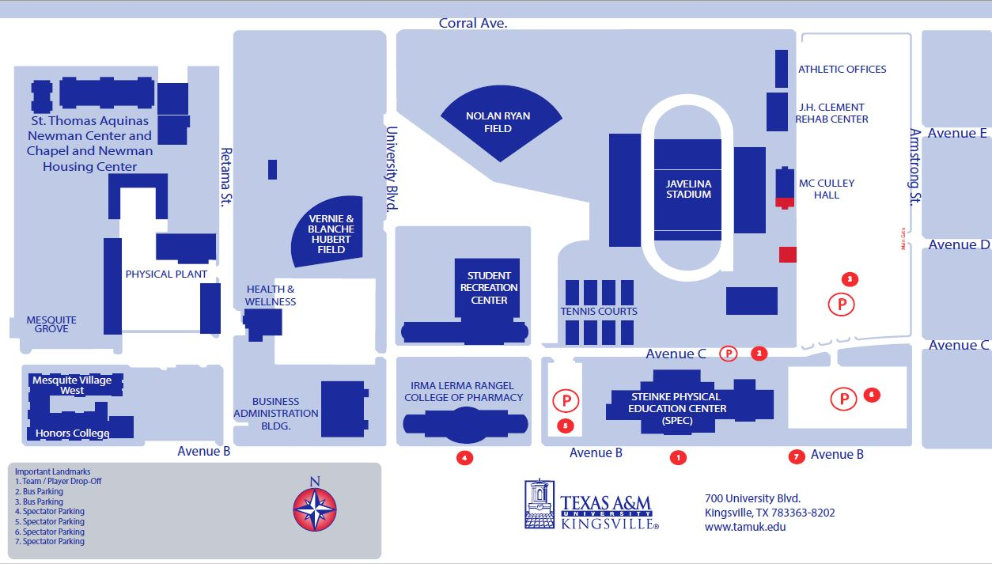

**5**