

**2022**

**REGIONAL BASKETBALL TOURNAMENTS**

**REGION IV - CONFERENCE 4A**

**----------------------------------------------------**

***GIRLS TOURNAMENT***

**FRIDAY, FEBRUARY 25 - SEMIFINAL GAME 1 at 6:00 PM**

**SEMIFINAL GAME 2 at 8:00 PM**

**SATURDAY, FEBRUARY 26 - CHAMPIONSHIP GAME at 3:00 PM**

**----------------------------------------------------**

***BOYS TOURNAMENT***

**FRIDAY, MARCH 4 - SEMIFINAL GAME 1 at 6:00 PM**

**SEMIFINAL GAME 2 at 8:00 PM**

**SATURDAY, MARCH 5 - CHAMPIONSHIP GAME at 3:00 PM**

**-----------------------------------------------**

**Texas A&M University-Kingsville**

**Steinke Physical Education Center**

**2022 UIL Regional Basketball Tournaments**

**Region IV Conference 4A**

**Girls Tournament – Friday & Saturday, February 25-26**

**Boys Tournament – Friday & Saturday, March 4-5**

**Texas A&M University-Kingsville**

**Tournament Directors**

David Brock, Office: 361/593-2500 [david.brock@tamuk.edu](mailto:david.brock@tamuk.edu).

Ruben Cantu, Office: 361/593-2493 ruben.cantu@tamuk.edu

**Pairings**

The Regional Tournament Bracket is a continuation of the UIL Basketball Playoff Bracket.

Teams in the Top section of the bracket will play Friday at 6:00 PM

Teams in the Bottom section of the bracket will play Friday at 8:00 PM

Home teams will be on the top of the pairings and will wear white or light jerseys.

Visiting teams will be on the bottom of the pairings and will wear dark jerseys.

The Girls Championship Game will be played on Saturday, February 26 at 3:00 PM

The Boys Championship Game will be played on Saturday, March 5 at 3:00 PM

**Tournament Host**

TAMU-Kingsville will be responsible for ticket sales, announcer, clock operator, security,

official scorebook, concessions, and custodial.

Schools participating in the regional tournament will be contacted regarding an entry fee.

**Area Games:** The head coach of the winning team’s Area Round Game needs to contact

David Brock **Cell: 361/246-7184**.

**Certification of Teams Qualifying for the Regional Tournament**

The head coach of each winning team’s Regional Quarterfinal Game needs to call David Brock,

Tournament Director, immediately after the conclusion of your quarterfinal game.

**Cell: 361/246-7184.**

**Programs For The Regional Tournaments**

Teams winning the Area Round Playoff Game must submit their **Team Information Form**

no later than **Monday, February 21 (Girls)** and **Monday, February 28 (Boys)**

Send to David Brock [david.brock@tamuk.edu](mailto:david.brock@tamuk.edu)*.* This form can be found on page 4.

**Officials for the Regional Tournaments**

Officials for the Regional Semifinal gameswill be determined by the two competing schools.

Officials for Regional championship games will be predetermined by the UIL**.**

**Coaches & School Administrator’s Meeting**

Friday, February 25 at 4:45 pm in the Steinke Center – Girls Tournament

Friday, March 4 at 4:45 pm in the Steinke Center – Boys Tournament

Brief review of tournament procedures for all head coaches and school administrators.

**1**

**Team Packets** may be picked up at the ticket counter in the lobby of the Steinke Center

beginning at 4:00 pm on Friday. Included will be five (5) tournament passes for each school.

**Game Ball** –Official game ball for the UIL playoff games is the Spalding Legacy TF-1000.

Bring a game ball if you are using the Spalding TF-1000. Bring practice balls.

No shooting on the court during half time, except for the two teams playing in that game.

**Bus Parking** -Schools are asked to follow these procedures for safety and convenience.

**Arrival -** Unload passengers and equipment on Avenue B - Street in front of the main entrance to the Steinke Center. Park all buses on Avenue C, back side of SPEC, next to the tennis courts. Schools sending “fan” buses or large vans are asked to follow same procedure.

**Departure -** Buses may pick up passengers at the front entrance of the Steinke Center.

**Pre-Game Warm Up Times**

Semi Final Game 1 – Friday at 6:00 PM

5:15 pm – Court opens for both the home & visiting team

5:55 pm – Player introductions and National Anthem

6:00 pm – Tip Off

Semi Final Game 2 – Friday at 8:00 PM

After the conclusion of Game 1 - Court opens for 30 minutes for both the home

and visiting team.

5 minutes prior to tip off – player Introductions.

Championship Game – Saturday at 3:00 p.m.

2:15 pm - Court opens for both the home and visiting teams

2:55 pm - Player introductions and National Anthem

3:00 pm - Tip Off

Immediately after the conclusion of the championship games the team championship trophy

and the team runner-up trophy will be presented on the court.

**Spectator Information & Ticket Sales**

Ticket Sales Begin / Doors Open: Friday at 5:00 PM; Saturday at 2:00 PM.

No Pre-Sale Tickets will be sold.

All seating in the Steinke Center is General Admission.

Ticket prices: Adults - $8.00; Students & Seniors - $5.00.

Parking lots adjacent to the Steinke Center are open for spectator parking.

Passes:There will be 5 tournament passes included in each school’s packet.

No district passes or coaches’ association passes accepted.

School groups in uniforms (cheerleaders) admitted without a pass.

Spectators are not allowed on the court at any time.

Only game officials are permitted seating at the scorer’s table.

Noise makers & releasing balloons are prohibited at all UIL athletic events held in gymnasiums.

The use of electronic flash/lighting equipment is also prohibited.

Hand held signs only. “Tasteful”

Cheerleaders in uniform are allowed access to the baseline areas. No halftime performances.

**2**

**Hotels and Dining:**

Schools are responsible for making their own housing reservations.

A complete list of TAMU-Kingsville Hotel and Dining Partners can be found on the

Javelina Athletics website:

<https://javelinaathletics.com/sports/2014/12/17/GEN_1217142653.aspx>

**Certification of Regional Champions**

A representative of the winning team needs to contact Brandy Belk, UIL Assistant

Athletic Director, (Cell: 512/635-6634) and Joseph Garmon, UIL Assistant Athletic Director

(Cell: 361-244-0497) immediately after the championship game to verify your team’s win/loss

record for seeding purposes at the State Tournament.

**UIL State Basketball Tournament**

Teams winning the **regional quarterfinal game** must submit their team’s materials

to the UIL office for the State Tournament no later than Monday, February 21, 2022

(Girls Basketball) and Monday, February 28, 2022 (Boys Basketball)

***Coaches need to refer to the 2021-2022 UIL Basketball Manual, page 25.***

https://www.uiltexas.org/files/athletics/manuals/Basketball_Manual_21-22.pdf

**Media Information**

**Media personnel need to contact TAMU-Kingsville Athletics Department prior to the**

**tournament for any specific needs / information.**

**Present media credentials at ticket booth for entrance into the gym.**

**Display these credentials at all times for access to court areas.**

**Photos** may be shot from the ends of the court. Photographers should be positioned off the playing court to allow both officials and players enough room to maneuver.

The use of electronic flash equipment is prohibited at all indoor UIL Championship events including volleyball and basketball.

**UIL Directive: No live streaming is permitted unless approval is received by TAMU-Kingsville from the UIL Office.** Media outlets interested in telecasting a playoff contest in any sport except football, must complete this form before noon the business day prior the event.

[https://www.uiltexas.org/machform/view.php?id=232455](https://nam04.safelinks.protection.outlook.com/?url=https%3A%2F%2Furldefense.proofpoint.com%2Fv2%2Furl%3Fu%3Dhttps-3A__www.uiltexas.org_machform_view.php-3Fid-3D232455%26d%3DDwQGaQ%26c%3DeuGZstcaTDllvimEN8b7jXrwqOf-v5A_CdpgnVfiiMM%26r%3DS155GO6ru79BouVgIlkqpcpNiwqJFijzSXxjINRvGaVxQgWonRYsxehvj-i2V5LG%26m%3DO9qmbg_wE6Z0xY__aDdGRH1FD1U3FfgpUXDPYvhxO_I%26s%3DXObVMHVVTViDrOF8yIRlOO_wf5dqkNdMz23FlPLubXs%26e%3D&data=04%7C01%7CDavid.Brock%40tamuk.edu%7C37f52a0c26834eabbfd408d90369c9a1%7C17420fd64d7546859adf7a650964dbcf%7C0%7C0%7C637544575169118395%7CUnknown%7CTWFpbGZsb3d8eyJWIjoiMC4wLjAwMDAiLCJQIjoiV2luMzIiLCJBTiI6Ik1haWwiLCJXVCI6Mn0%3D%7C1000&sdata=UcrHB5sUcTZyPZxub5xhhjJy%2Bq%2Fx4o7txg9zuUaKUYo%3D&reserved=0)

Questions on media coverage:

David Brock, TAMU-Kingsville Athletic Dept. (361) 593-2500. [david.brock@tamuk.edu](mailto:david.brock@tamuk.edu).

**3**

**Team Information Form for the Regional Basketball Tournament**

**Complete and return to David Brock, TAMU-Kingsville. E-mail to:** [**david.brock@tamuk.edu**](mailto:david.brock@tamuk.edu)

**Deadline**: Monday, February 21, 2022 - for the Girls Regional Tournament

**Deadline**: Monday, February 28, 2022 - for the Boys Regional Tournament

**SCHOOL: _______________________________________ MASCOT:____­­­_____________________________**

**TEAM COLORS: __________________________________________ UIL DISTRICT NUMBER: _______**

**SEASON RECORD: Wins- _____ Losses- _____ *(Including the Win in the Regional Quarterfinal Game)***

**CURRENT SCHOOL ENROLLMENT (Grades 9-12) _______**

**NUMBER OF TIMES IN THE REGIONAL TOURNAMENT *(Including this year*) ______**

**List in Numerical Order. Typewritten Only.**

**Jersey Number Name Class (9-12) Ht. Position**

Ex.> 00 Mary Smith 12 5-8 G/F

**Head Coach: __________________________________ College Attended _____________________________**

**Assistant Coaches:__________________________________________________________________________**

**Athletic Director: __________________________________________________________________________**

**Principal: _________________________________________________________________________________**

**Superintendent: ____________________________________________________________________________**

**Trainer:___________________________________________________________________________________**

**Student Managers:__________________________________________________________________________**

**4**

**2022 UIL REGIONAL BASKETBALL TOURNAMENT**

**SCHOOL BUS PARKING**

**SPECTATOR PARKING**

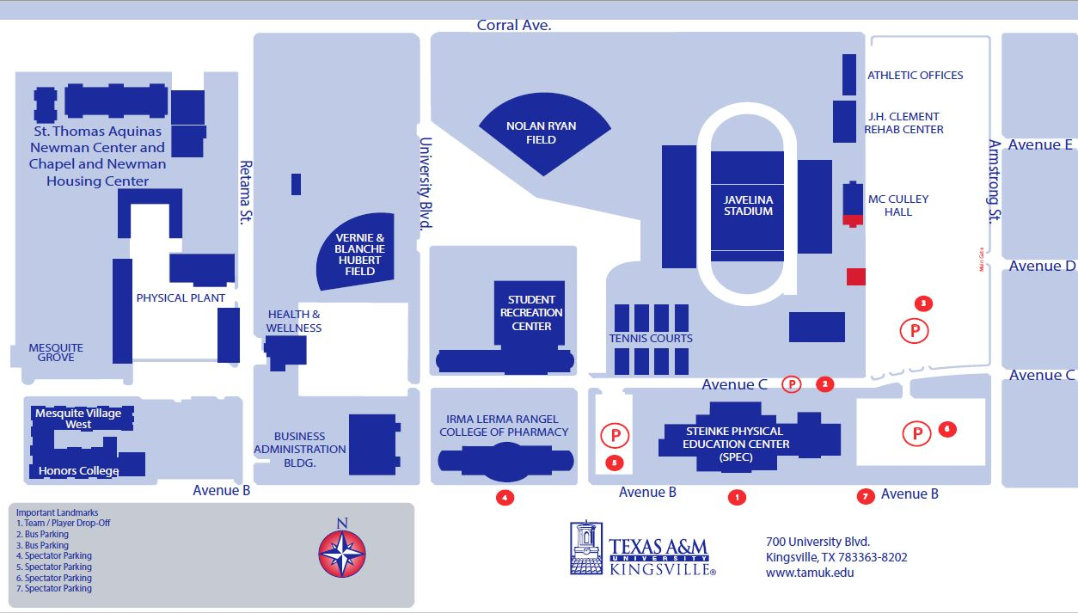

**5**