2020

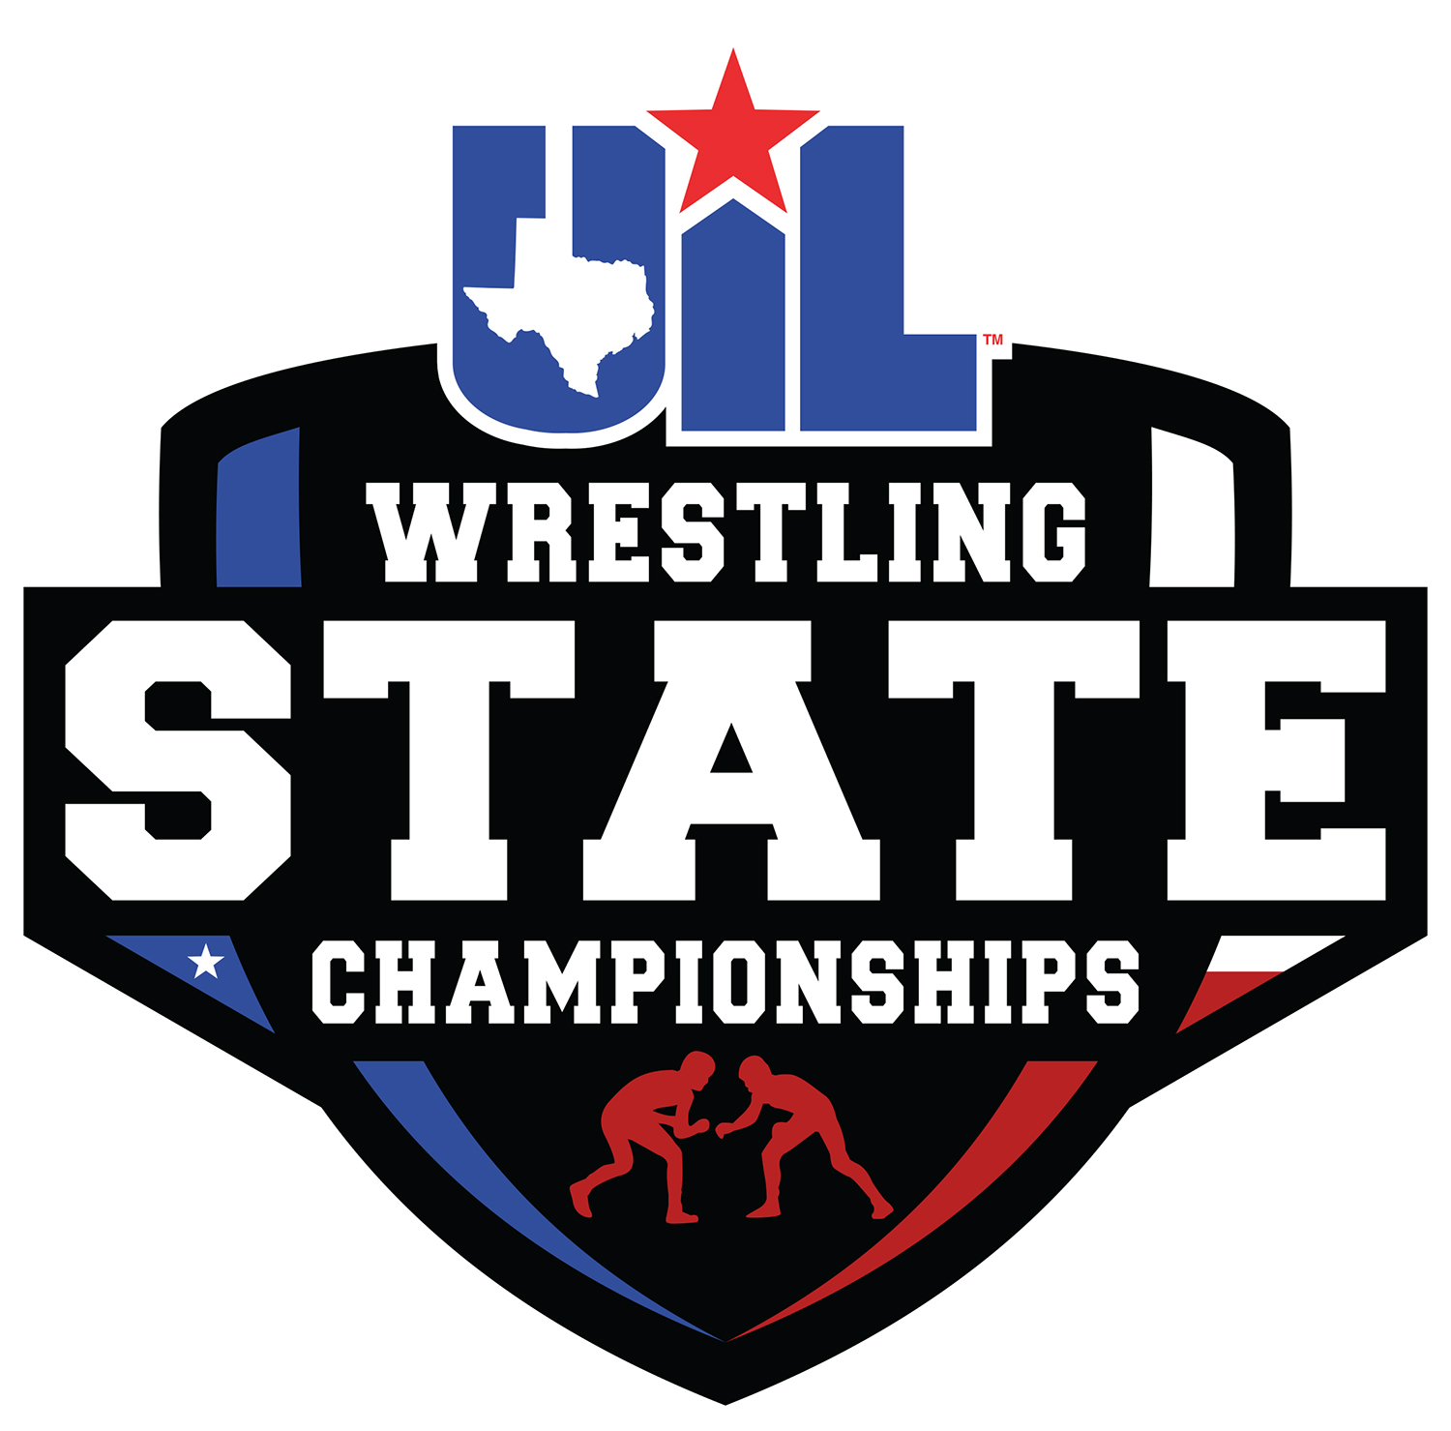

WRESTLING
State Qualifier’s
Handbook
UNIVERSITY INTERSCHOLASTIC LEAGUE

STATE QUALIFIER’S HANDBOOK

2020 WRESTLING

Congratulations on your team’s advancement to the Wrestling State Tournament. This handbook has been prepared to serve as a guide to administrators and coaches and provide information about the state tournament. You will find this material valuable as you prepare for the meet and upon your arrival to the meet.

Questions concerning the UIL Wrestling State Tournament should be addressed to the following staff members:

Dr. Susan Elza, Ed.D. – UIL Director of Athletics
selza@uiltexas.org

A.J. Martinez – Tournament Director
ajmartinez@uiltexas.org
(512) 232-4140

Crystal Victorino – Assistant to Tournament Director
cvictorino@uiltexas.org
(512) 232-4938

Table of Contents

Tournament Information 3
Tournament Schedule 5
Important Information 6
Credentials/Tattoos Information 6
Weigh-In Information 7
Awards Information 8
Maps 10

TOURNAMENT INFORMATION

2020 UIL Wrestling State Championships
February 21-22, 2020
Berry Center: Cypress, Texas

Tournament Director. A.J. Martinez will serve as the tournament director. The tournament director and rules committee members shall rule on all state tournament wrestling rule situations.

School Packets. School packets will be available for pickup from 4:00 – 6:00 pm on Thursday, February 20th and beginning at 6:00 am, Friday, February 21st, in the Atrium of the Berry Center through Entrance 3. One program per school will be included in the school packets. Additional programs may be purchased from the program sellers.

Coaches’ Meeting. There is a mandatory coaches’ meeting on Thursday, February 20th at 5:30 pm in the Theatre of the Berry Center. Specific tournament information will be covered for you at this meeting.

Coach/Trainer Credentials. Each school team (boys and girls) will be given TWO coach wristbands, these wristbands will be valid for access to the arena floor throughout the tournament. Trainers may request a wristband directly from A.J. Martinez or Crystal Victorino at the tournament.

Student Manager/Student Trainer Credentials. Each school team (boys and girls) will be given ONE complimentary pass for student managers/trainers. This pass will not allow arena floor access but will get them in the tournament each day. No additional passes for student managers/trainers will be given, and they must keep up with their pass to be used for both days.

Locker Rooms. There will be locker rooms for both boys and girls available. Those locker rooms will be labeled on a map included in your school packet.

Food and Drinks. Teams will be allowed to bring in food and drinks at the beginning of each day through Entrance 3 only, and up until 11:00 am. Parents can bring kids food up until 11:00 am through Entrance 3, only by meeting a coach at the entrance. There will be a pre-order box meal option for teams through the Berry Center. Flyer for those meals are on our website.

Weigh-Ins. Weigh-ins for the UIL Wrestling State Championships will be held on both the arena floor and conference room at the Berry Center (girls/boys) and in accordance with Rule 4-5 of the National Federation Wrestling Rule Book. The times for official weigh-ins are listed in the state tournament schedule. These times will not be altered or extended. Detailed information of the weigh-in procedure will be included in your school packet upon arrival. PLEASE DO NOT BRING BAGS OR ADDITIONAL ITEMS INTO THE WEIGH-IN AREA until after weigh-ins are complete. Pre-weigh is available in the regular weigh-in area. Girls will need to wait until boys’ weigh-in is finished before going to regular weigh-in area.
- Alternates will be weighed in!
- TATTOOS will be picked up at the scales for competitors

Warm-Up Area. A warm-up area will be provided and is in conjunction with the staging area. See map for location.

Alternates. Alternates will be weighed in with the other competitors. Alternates will be placed in the bracket if the advancing wrestler is unable to attend. Once weigh-ins for a particular weight class begins, there will be no substitutions. Alternates will not replace wrestlers who fail to make weight. Each alternate will be given a complimentary pass to be used for both days.

Athletes and coaches that have qualified for Saturday’s finals are required to check-in Saturday between 4:00-4:15pm in the staging area (Atrium outside the arena) to prep for the Parade of Champions.

Team Honors. UIL will score six places for the boys and six places for the girls at the state tournament. In district, regional and state tournaments, team honors shall be determined by the National Federation scoring standards detailed in the wrestling rule book.

Awards. The top three finishers in each weight class will receive medals from the UIL. The top THREE teams will receive trophies. This is a special time for both athletes and coaches. All athletes need to be dressed appropriately and on time to the award ceremony.
- Participant Attire: sweat pants, a school logoed top/t-shirt, no headgear of any kind.

Unsportsmanlike Conduct. According to National Federation rules, all points accumulated by a wrestler who is disqualified for an unsportsmanlike conduct violation will be deducted from the team score.

Photos. 1st Photo Texas will be taking photos at the awards stand. Please visit the 1st Photo Texas’ website to order photos (www.1stphototexas.com).

Tickets. The doors will open and tickets will be available to the public one hour prior to competition each day. All seating is general admission.

Ticket prices:
Adults $12.00
Students $7.00 per day
All-Tournament Pass $20.00
Coach/Official Tournament Pass $17.00.
**No pre-sale tickets will be available.

Parking. Parking at the Berry Center is free. Please see attached map for parking assignments. Teams will park in lots “C” and “D” Thursday through Saturday and enter through Entrance 3.

Noisemakers/Signs. No artificial noisemakers or large signs/banners are allowed.

Wrestling State Tournament Broadcast Information. NFHS Network will provide a live webcast of the 2020 UIL Wrestling State Tournament on Feb. 21-22 from the Berry Center in Cypress, Texas.

Fans, family and alumni unable to attend the event can watch Friday and Saturday matches of the UIL Wrestling State Tournament live online with a subscription at www.nfhsnetwork.com/associations/uil. Subscribers can also watch on the go by downloading the NFHS Network app for iPhone and Android devices.

The live webcast will begin on NFHSNetwork.com on Friday, Feb. 21 at 9 a.m. CT, each mat will have an individual video stream on the NFHS Network.

2020 STATE WRESTLING COMPOSITE SCHEDULE

Thursday, Feb. 22nd
TIME | CLASS | DIVISION | ACTIVITY | LOCATION
3a:00 PM |  |  | THSCA Adv. Meeting | Theatre
4:00 – 6:00 PM | 5A/6A | BOYS/GIRLS | Team Registration | Command Center  (West Side Concourse)
4:00 – 7:00 PM | 5A/6A | BOYS/GIRLS | Mat Time/Weight Check | Arena Floor
4:00 – 7:00 PM | 5A/6A | BOYS/GIRLS | Weight Check | Conference Center
**5:30 Head Coaches’ Meeting in Berry Center Theater
**5:45 Officials Meeting in Berry Center “Officials Room”

Friday, Feb. 21st
TIME | CLASS | DIVISION | ACTIVITY | LOCATION
6:00 AM | 5A/6A | ALL | Doors Open | Entrance #3
7:00 AM | 5A/6A | BOYS | Weigh-In | Line up on Arena floor by weight class;  (Weigh-In Occurs in Conference Center)
8:30 AM | 5A/6A | BOYS | Championship Round 1 | 5A Boys Mats 1-5; 6A Boys Mats 6-10
9:30 AM | 5A/6A | GIRLS | Weigh-In | Berry Center Atrium & Conference Center
11:00 AM | 5A/6A | GIRLS | Championship Round 1 | 5A Girls Mats 1-5; 6A Girls Mats 6-10
12:30 PM |  |  | Mat Cleaning/Break
1:00 PM | 5A/6A | BOYS | Champ. Quarters and 1st Rd. Cons. | 5A Boys Mats 1-5; 6A Boys Mats 6-10
3:30 PM | 5A/6A | GIRLS | Champ. Quarters and 1st Rd. Cons. | 5A Girls Mats 1-5; 6A Girls Mats 6-10
5:00 PM | 5A/6A | BOYS | Second Round Consolation | 5A Boys Mats 1-5; 6A Boys Mats 6-10
6:15 PM | 5A/6A | GIRLS | Second Round Consolation | 5A Girls Mats 1-5; 6A Girls Mats 6-10

Saturday, Feb. 22nd
TIME | CLASS | DIVISION | ACTIVITY | LOCATION
6:00 AM | 5A/6A | ALL | Doors Open | Entrance #3
7:00 AM | 5A/6A | BOYS | Weigh-In | Line up on Arena floor by weight class;  (Weigh-In Occurs in Conference Center)
8:30 AM | 5A/6A | BOYS | Champ. Semifinals and 3rd Rd. Cons. | 5A Boys Mats 1-5; 6A Boys Mats 6-10
9:00 AM | 5A/6A | GIRLS | Weigh-In | Berry Center Atrium & Conference Center
10:30 AM | 5A/6A | GIRLS | Champ. Semifinals and 3rd Rd. Cons. | 5A Girls Mats 1-5; 6A Girls Mats 6-10
12:00 PM | 5A/6A | BOYS | Consolation Semifinals | 5A Boys Mats 1-5; 6A Boys Mats 6-10
1:00 PM | 5A/6A | GIRLS | Consolation Semifinals | 5A Girls Mats 1-5; 6A Girls Mats 6-10
2:00 PM |  |  | Mat Cleaning/Break
2:30 PM | 5A | BOYS | 3rd and 5th Place Matches | 3rd Place Matches 3, 5th Place Matches 2
 | 5A | GIRLS | 3rd and 5th Place Matches | 3rd Place Matches 4, 5th Place Matches 5
 | 6A | GIRLS | 3rd and 5th Place Matches | 3rd Place Matches 7, 5th Place Matches 6
 | 6A | BOYS | 3rd and 5th Place Matches | 3rd Place Matches 8, 5th Place Matches 9
4:15 PM |  |  | NFHS Coach of the Year & HOF Inductees | Arena Floor (Reduce # of Mats)
4:30 PM |  |  | Parade of Champions | Arena Floor (4 Mats)
4:45 PM | 5A/6A | BOYS | Championship Matches | 5A Boys Mat 1; 6A Boys Mat 4
 | 5A/6A | GIRLS | Championship Matches | 5A Girls Mat 2; 6A Girls Mat 3

IMPORTANT INFORMATION

Parking. Lots “C” and “D”.

Entrance. School/Team/Coach enters through Entrance 3.

Food and Drinks. Bring through Entrance 3 with Team until 11:00 am! Parents may bring in food for kids up until 11:00 am ONLY and must bring it through Entrance 3 by meeting with the school coach at the entrance.

Weigh-In. Have athletes (qualifiers & alternates) on time and ready to go in accordance to NFHS Rules (Boys line up on Arena Floor; Girls line up in Atrium Hallway @ appropriate times).

Schedule. 10 Mats; 5A and 6A are split; Athletes will make their way to the Arena floor from the staging (warm-up room) for their matches.

Athletes. Only athletes that have their tattoo and singlet on will be allowed on the arena floor. No boy or Girl athlete will be allowed on the floor while the other gender is wrestling.

Student Trainers/Managers. They will be allowed in the atrium and warm-up areas, but they will not be allowed on the arena floor with their complimentary pass.

Coach Seating. There will be seats for coaches to sit in on the floor. During finals, all coaches without a competing wrestler should be seated in the designated coaching seats on the concourse level. (Located beneath Control Center/designated for COACHES only)

Parade of Champions. Line up in the Atrium outside the Arena Floor @ 4:00 pm.

Awards. 1st through 6th place; Start after Final Matches have begun; Have kids on time and dressed appropriately. Parents/spectators are not permitted in the awards area.

Rules Committee.
AJ Martinez – Tournament Director (361) 816-1281
Rex Anderson – Head Referee (281) 814-2901
Dan Lang – Rules Interpreter (281) 684-7720

CREDENTIALS AND TATTOOS

Credentials. Each school will be given 2 wristbands per team (boys and girls) for coaches. You may be given more wristbands depending on the number of qualifiers you have. Only 2 coaches should be on the floor at one time. *Trainers (adult trainers) can get a wristband in person from A.J. Martinez or Crystal Victorino.

Tattoos (Boys & Girls). Athletes will be issued tattoos for each day at the scales for weigh-ins. If an athlete has a tattoo rub off, they can come to the UIL Office to receive a new one from A.J. Martinez or Crystal Victorino.

Temporary Tattoo Directions:

- Skin should be clean and free of oils and makeup.
- Remove clear, protective top sheet.
- Press tattoo firmly onto clean, dry skin, with design facing down.
- Hold wet paper towel or cloth against back of tattoo, press down and make sure to wet it thoroughly.
- Wait 30 seconds (don’t hurry). Peel off paper backing.
- Gently rinse image with water for best effect.

TATTOOS MUST BE DISPLAYED ON THE TOP OF THE HAND.

**Warning: Don’t apply to sensitive skin or near eyes.

To Remove. Saturate tattoo with household rubbing alcohol or baby oil; wait 10 seconds, then rub away tattoo with a cotton ball OR lift tattoo from dry skin using several pieces of transparent household tape.

WEIGH-IN INFORMATION

Weigh-ins will be conducted in the conference center that is adjacent to the warm-up area. Below is a description of the format we will use for both boys and girls and will be in accordance with Rule 4-5 of the National Federation Wrestling Book. All qualifying athletes, along with alternates, will be weighed in at the same time.

*Mark Lyons will be the lead for the weigh-ins.

Boys:
Weigh-in staging area: The boys will all report to the arena floor for weigh-ins. We will line up the boys by weight class, in single file, by ranking order (14 lines). We will then proceed to walk each weight class to the weigh-in area. Once a weight class is completed, we will walk the next weight class down.

Girls:
Weigh-in staging area: The girls will all report to the atrium for weigh-ins (between the arena floor and the warm-up area). We will line up the girls by weight class, in single file, by ranking order (10 lines). We will then proceed to walk each weight class to the weigh-in area. Once a weight class is completed, we will walk the next weight class down.

Weigh-Ins will be conducted at the following times:

Friday, February 21st
- 7:00 am – Boys Weigh-Ins
- 9:30 am – Girls Weigh-Ins

Saturday, February 22nd
- 7:00 am – Boys Weigh-Ins
- 9:00 am – Girls Weigh-Ins

All participants must remain in the weigh-in area when weigh-ins begin.

As stated in the National Federation Rules, activities that promote dehydration are prohibited in the weigh-in area. Individuals found to be in violation of this rule will be disqualified from participation in the tournament.

*There will be a physician on site during the weigh-in.

**Rex Anderson, Dan Lang, and A.J. Martinez will be available for any questions/concerns pertaining to the weigh-in!

PARADE OF CHAMPIONS/AWARDS PRESENTATIONS

Parade of Champions.
Athletes
Athletes will line up in the Atrium of the Berry Center by weight classes beginning with 5A Boys, 5A Girls, 6A Girls, 6A Boys. They will then be escorted out to the arena floor (go right) and will continue walking around the arena to their designated mat.

Coaches
Coaches will line up next to their athletes in their perspective lines. As athletes are being escorted to the right after entering the arena, coaches will go left and line up in rows along the end and wait for Parade of Champions to conclude.

Awards. Individual weight class awards according to page 10:

- The weight class order is listed on page 10
- There is a separate podium for both 5A and 6A competitors
- We should have 24 stacks of medals total; put Gold on bottom and work up
- We will award the classes by alternating between the girls and boys (Ex. – 95lb Class: 5A Girls then 6A Girls; then 106lb Class: 5A Boys then 6A Boys)
- **A.J. will relay to Kat when each presentation is set to announce**

Once all weight classes are awarded we will move to the overall awards.

Individual:
5A Girls Outstanding Wrestler
6A Girls Outstanding Wrestler
5A Boys Outstanding Wrestler
6A Boys Outstanding Wrestler

Team: (announce teams to come to designated podium when called)
3rd Place 5A Girls
3rd Place 6A Girls
3rd Place 5A Boys
3rd Place 6A Boys

2nd Place 5A Girls
2nd Place 6A Girls
2nd Place 5A Boys
2nd Place 6A Boys

1st Place 5A Girls
1st Place 6A Girls
1st Place 5A Boys
1st Place 6A Boys

AWARDS PRESENTATION “DETAIL”

The top 6 finishers are to report to the awards area immediately and must be wearing the appropriate attire (warm-up bottoms, a school logoed top, no head gear), so please make sure your athletes are readily available. The 3rd through 6th place finishers will wait until the championship match has concluded to participate in the awards Ceremony.

4:30 pm
- Parade of Champions
- National Anthem

4:45pm – Championship Matches Begin

GIRLS (Mats 2 & 3) BOYS (Mats 1 & 4)
95 Weight Class 106 Weight Class
102 Weight Class 113 Weight Class
110 Weight Class 120 Weight Class
AWARDS 95 WEIGHT CLASS AWARDS 106 WEIGHT CLASS
119 Weight Class 126 Weight Class
AWARDS 102 WEIGHT CLASS AWARDS 113 WEIGHT CLASS
128 Weight Class 132 Weight Class
AWARDS 110 WEIGHT CLASS AWARDS 120 WEIGHT CLASS
138 Weight Class 138 Weight Class
AWARDS 119 WEIGHT CLASS 126 WEIGHT CLASS
148 Weight Class 145 Weight Class
AWARDS 128 WEIGHT CLASS AWARDS 132 WEIGHT CLASS
165 Weight Class 152 Weight Class
AWARDS 138 WEIGHT CLASS AWARDS 138 WEIGHT CLASS
185 Weight Class 160 Weight Class
AWARDS 148 WEIGHT CLASS AWARDS 145 WEIGHT CLASS
215 Weight Class 170 Weight Class
AWARDS 165 WEIGHT CLASS AWARDS 152 WEIGHT CLASS
182 Weight Class
AWARDS 148 WEIGHT CLASS AWARDS 160 WEIGHT CLASS
195 Weight Class
AWARDS 148 WEIGHT CLASS AWARDS 170 WEIGHT CLASS
220 Weight Class
AWARDS 182 WEIGHT CLASS
285 Weight Class
AWARDS 195, 220, 285 WEIGHT CLASS

GIRLS COACH OF THE YEAR
BOYS COACH OF THE YEAR
5A GIRLS OUTSTANDING WRESTLER
6A GIRLS OUTSTANDING WRESTLER
5A BOYS OUTSTANDING WRESTLER
6A BOYS OUTSTANDING WRESTLER
GIRLS TEAM TROPHIES
BOYS TEAM TROPHIES

- We will begin awards after 3 weight classes have wrestled
- 1ST through 6th place awarded with medals (1st – 3rd “U.I.L.”, 4th – 6th “W.A.”)
- Trophies and Plaques will be awarded once all weight classes have been awarded

PARKING AND ENTRANCE MAP

Team Parking: Lot D
Team Entrance: Entrance Three

Spectator Parking: Lots A and B
Spectator Entrance: Entrance Two

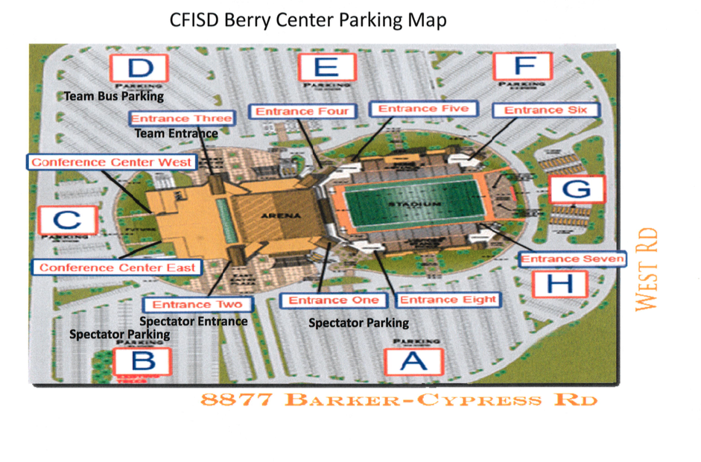

BERRY CENTER LAYOUT

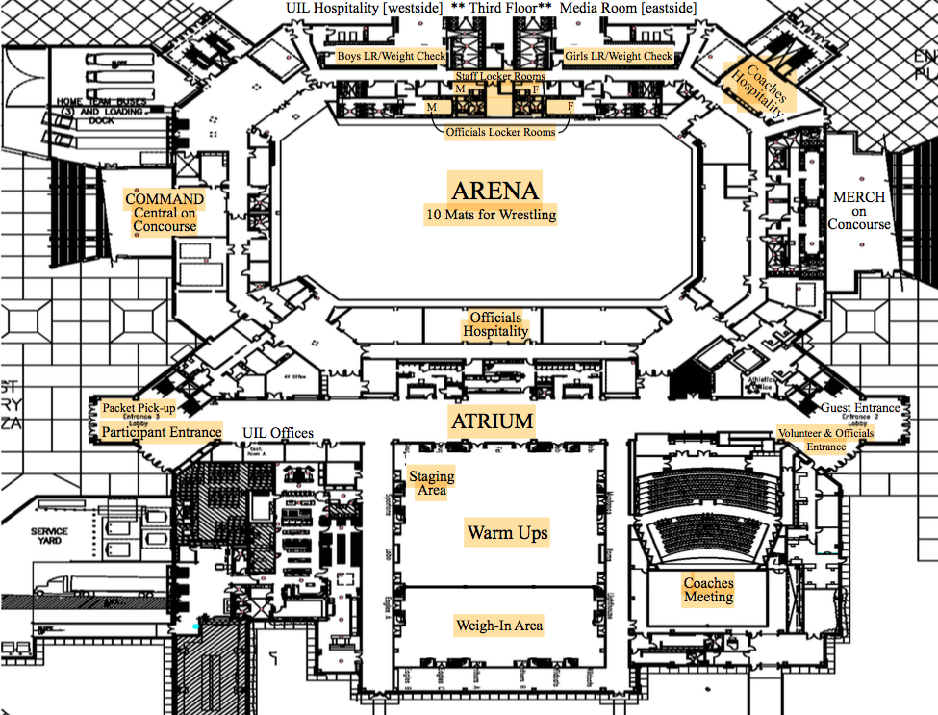

ARENA FLOOR

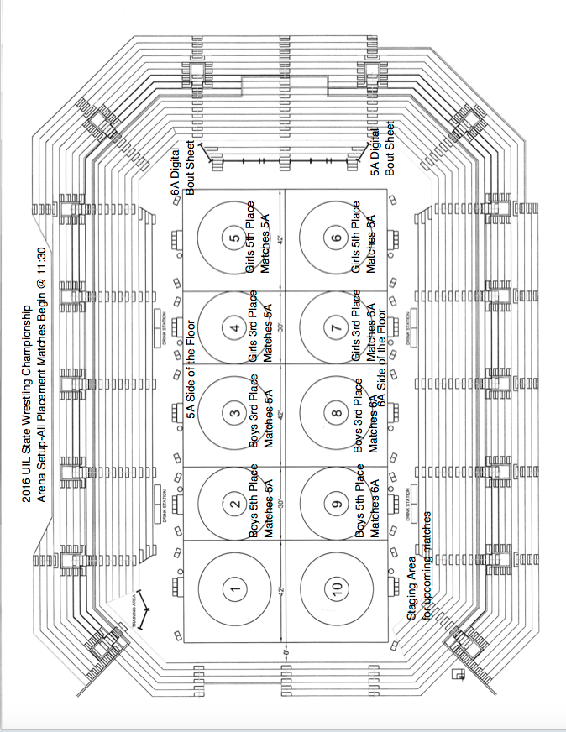
2020 UIL State Wrestling Championships

