2020

REGION IV CONFERENCE 4A
REGIONAL BASKETBALL TOURNAMENTS
COACHES MANUAL

GIRLS REGIONAL BASKETBALL TOURNAMENT
FRIDAY, FEBRUARY 28 – SEMIFINAL GAMES
GAME 1 – 6:00 PM GAME 2 – 8:00 PM

SATURDAY, FEBRUARY 29 - CHAMPIONSHIP GAME - 7:30 PM

BOYS REGIONAL BASKETBALL TOURNAMENT
FRIDAY, MARCH 6 – SEMIFINAL GAMES
GAME 1 – 6:00 PM GAME 2 – 8:00 PM

SATURDAY, MARCH 7 - CHAMPIONSHIP GAME - 3:00 PM

Texas A&M University-Kingsville
Steinke Physical Education Center (SPEC)

2020 UIL Regional Basketball Tournaments
Region IV Conference 4A

Girls Tournament – Friday & Saturday, February 28-29
Boys Tournament – Friday & Saturday, March 6-7

Location: Texas A&M University-Kingsville, Steinke Physical Education Center (SPEC)

Tournament Directors
David Brock, Office: 361/593-2500 Cell: 361/246-7184 david.brock@tamuk.edu.
Ruben Cantu, Office: 361/593-2493 ruben.cantu@tamuk.edu

Girls & Boys Regional Tournament Pairings
- The Regional Tournament Bracket is a continuation of the UIL Basketball Playoff Bracket.
- Teams in the Upper section of the bracket will play Friday at 6:00 pm
- Teams in the Lower section of the bracket will play Friday at 8:00 pm
- The Girls Championship Game will be played Saturday, February 29 at 7:30 pm.
- The Boys Championship Game will be played on Saturday, March 7 at 3:00 pm
- Home teams will be on the top of the bracket and will wear white or light jerseys.
- Visiting teams will be on the bottom of the bracket and will wear dark jerseys.

Ticket Information
- Ticket prices: Adults-$8.00; Students & Seniors-$5.00
- No Pre-Sale Tickets sold.
- Ticket Booth Sales/Doors Open:
Friday - 5:00 pm; Saturday – 1 Hour prior to game time.
- Passes: There will be 5 tournament passes in each school’s packet
- No District Passes; No Coaches’ Associations Passes
- School groups in uniforms (cheerleaders) admitted without a pass.

School Administrators
- TAMU-Kingsville, Javelina Athletics, will be responsible for ticket sales, security, announcer, clock operator, official scorebook, concessions, and custodial.
- Coaches & Game Administrator’s Meeting:
Friday, 2/28/20 (Girls) and Friday, 3/6/20- (Boys) - 4:45 pm in the Steinke Center.
Brief review of tournament procedures for all head coaches and each school’s administrator.
- Hand held signs only. “Tasteful”
- Noise makers are prohibited at all UIL athletic events held in gymnasiums.
- Cheerleaders in uniform are allowed access to the baseline areas. No halftime performances.
- Spectators are not allowed on the court at any time.
- The UIL Financial Report for Basketball Playoff Games will be sent to each participating
school after conclusion of the tournament.
- Schools participating in the Regional Tournament will be contacted regarding Tournament
Entry Fee.
1

Coaches Information For The Regional Tournaments

- Area Games: The head coach of the winning team’s Area Game needs to contact
David Brock - Cell: 361/246-7184.

- Certification of Regional Tournament Teams: The head coach of each winning team’s
Regional Quarterfinal Game needs to call David Brock, Tournament Director, immediately
after the conclusion of your Regional Quarterfinal game. Cell: 361/246-7184.

- Programs For The Regional Tournaments
Teams winning the Area Round Playoff Game must submit their Team Information Form
no later than Monday, February 24 (Girls) and Monday, March 2 (Boys)
Send to David Brock david.brock@tamuk.edu. This Form can be found on page 4.

- Officials for the Regional Tournaments
Officials for the Regional Semifinal games will be determined by the two competing schools.
Officials for Regional Finals game will be predetermined by the UIL.

- Coaches & Game Administrator’s Meeting:
Friday, February 28 at 4:45 pm in the SPEC. – Girls Tournament
Friday, March 6 at 4:45 pm in the SPEC – Boys Tournament
Brief review of tournament procedures for all head coaches and each school’s administrator.

- Team Packets may be picked up at the ticket counter in the lobby of the gym (SPEC) beginning at 4:00 pm on Friday. Included will be five (5) passes for each school. .

- Pre-Game and Post-Game Time Schedules can be found of page 5.

- Hotels: Each school is responsible for its own housing. A listing of hotels in the
Kingsville area can be found of page 7.

- Bring a Game Ball - Spalding TF1000 Platinum. Bring your own Practice Balls.

Other Items:
* Protests based on a decision of a game official will not be permitted (C&CR)
* No shooting on the court during half time, except for the two teams playing in that game.
* Only Game Officials are permitted seating at the Scorer’s Table.
* TAMU-Kingsville Athletic Trainers will be available.
.
- UIL State Tournament - Team Information & Pictures. Teams winning the regional quarterfinal game must submit their materials to the UIL no later than Monday, February 26, 2020 (Girls Basketball) and Monday, March 4, 2020 (Boys Basketball):
Refer to the 2019-2020 UIL Basketball Manual, page 23

2

Spectator Information
- All seating in the Steinke Center (SPEC) is General Admission.
- Parking lots & streets adjacent to the Steinke Center are open for spectator parking.
There is no charge for parking.
- Spectators are not allowed on the court at any time.
- Noise makers are prohibited at all UIL athletic events held in gymnasiums.
- The use of electronic flash/lighting equipment is prohibited.

Bus Parking - Schools are asked to follow these procedures for safety and convenience.
*Refer to Parking Map on page 8
Arrival
- Unload players, and equipment on Avenue B - Street in front of the main entrance to the Steinke Center. Park all buses on Avenue C, back side of SPEC, next to the tennis courts.
Schools sending “fan” buses or large vans are asked to follow same procedure.

Departure
- Buses may use this same location for passenger pick-up – Avenue B.

Media
- Media personnel need to contact TAMU-Kingsville, prior to each tournament, for any specific needs / information.
- Present media credentials at ticket booth for entrance into the gym. Display these credentials at all times for access to court areas.
- Photos may be shot from the ends of the court. Photographers should be positioned off the playing court to allow both officials and players enough room to maneuver.
- FLASH PHOTOGRAPHY: The use of electronic flash equipment is prohibited at all indoor UIL Championship events including volleyball and basketball.
- Questions on Media coverage: David Brock, TAMU-Kingsville Athletic Dept. (361) 593-2500
Jon Montoya, Assistant A.D. for Sports Information (361) 593-2870

Certification of Regional Champions
A representative of the winning team needs to contact Brandy Belk, UIL Assistant Athletic Director, (cell: 512/635-6634) immediately after your Regional Championship game to verify team win/loss records for seeding purposes at the State Tournament.

3

Team Information Form for the Regional Basketball Tournament
Complete and return to David Brock, TAMU-Kingsville. E-mail to: david.brock@tamuk.edu
Typewritten Only
Deadline: Monday, February 24, 2020 - for the Girls Regional Tournament
Deadline: Monday, March 2, 2020 - for the Boys Regional Tournament

SCHOOL:_______________________________________ MASCOT:________________________________
TEAM COLORS: __________________________________________ UIL DISTRICT NUMBER _______
SEASON RECORD: Wins- _____ Losses- _____ (Including Win in the Regional Quarter-Final Game)
CURRENT SCHOOL ENROLLMENT (Grades 9-12) _______
NUMBER OF TIMES IN THE REGIONAL TOURNAMENT (Including this year) ________
(List in Numerical Order)
Jersey Number Name Class (9-12) Ht. Position
Ex.> 00 Mary Smith 12 5-8 G/F

Head Coach: _________________________________ College Attended _________________________
Assistant Coaches:_____________________________________________________________________
Athletic Director: _____________________________________________________________________
Principal: ____________________________________________________________________________
Superintendent: ______________________________________________________________________
Trainer:______________________________________________________________________________
Student Managers:_____________________________________________________________________
4

PRE-GAME TIME SCHEDULES
2020 GIRLS & BOYS REGIONAL BASKETBALL TOURNAMENTS
UIL REGION IV – CONFERENCE 4A

------------------------------------------------

REGIONALTOURNAMENT SEMI FINAL GAMES

Girls Tournament: Friday, February 28, 2020
Boys Tournament: Friday, March 6, 2020

Game 1: Regional Semi Final – 6:00 PM
5:15 pm – Court opens for both Home & Visiting Teams
5:55 pm – Player Introductions and National Anthem
6:00 pm – Tip Off

Game 2: Regional Semi Final – 8:00 PM
After the court clears – Court opens for 30 minutes for both Home & Visiting Teams.
5 minutes prior to Tip Off – Player Introductions.

------------------------------------------------

REGIONAL TOURNAMENT CHAMPIONSHIP GAMES

Girls Championship Game - Saturday, February 29, 2020 – 7:30 p.m.
Boys Championship Game - Saturday, March 7, 2020 – 3:00 p.m.

30 Minutes prior to Tip-Off - Court opens for both Home and Visiting Team
5 Minutes prior to Tip-Off - Player introductions and National Anthem

------------------------------------------------

POST-GAME
Saturday, February 29, 2020 and Saturday, March 7, 2020

Immediately after the conclusion of the Champion Games –
Team Championship Trophy and the Team Runner-Up Trophy will be presented on the Court.

5
CORPORATE DINING PARTNERS
TEXAS A&M UNIVERSITY-KINGSVILLE
JAVELINA ATHLETICS
Call in Advance for Group/Team Services

Aramark: TAMU-Kingsville - Dining Services
361/403-3114, Ms. Jackie Flores, Catering Director
361/593-3119; Javelina Dining Services Office
Javelina Dining Hall Services Available
Take-out orders: Chick-fil-A; Pizza Hut Express; Subway; Starbucks

Blue Ribbon Deli & Coffee Bar
361/516-0208; 1036 S. 14th Street; Juan Vidal, Owner
Dine-in or Take-out for breakfast, lunch and dinner

Bray's Smokehouse
361-221-1100; 1500 S Brahma Blvd.
Justin Bray, Owner

Domino’s Pizza
361/595-5591; 309 East King Ave. Hours: 10:30 a.m. to 1:00 a.m.

El Corral Restaurant
361/592-7622 and 361/592-1574 1415 N. 14th Street
Tex-Mex Restaurant - Dine in or Take-out
Open for Breakfast, Lunch & Dinner

Fatman's Meat Market, Processing & Catering
361/459-4142
217 E. Main St. Bishop, TX

Pizza Parlor
361/592-8842; 816 West King Ave
Beth Dembski, Owner

Young’s Pizza, Inc.
361/592-9179; 625 W. Santa Gertrudis Blvd; Scott Conard, Owner
Located 4 Blocks from the Steinke Center

Whataburger Restaurants
Location # 1: 361/592-4356; 510 S. 14th Street
Location # 2: 361/221-9559; 2701 US Hwy 77 South, By-Pass

6

CORPORATE HOTEL PARTNERS
TEXAS A&M UNIVERSITY-KINGSVILLE
JAVELINA ATHLETICS
ASK ABOUT GROUP/TEAM RATES

Americas Best Value Inn – Kingsville
361/593-5656 2204 E. King Ave. Kingsville, TX 78363
Mr. Neil Bhakta, Manager/Owner

Emerald Beach Hotel
361/883-5731 1102 S. Shoreline Blvd., Corpus Christi, TX 78401
Full Service Hotel (Only hotel in downtown Corpus Christi on the beach)
Debi Tomberlin, Director of Sales

La Quinta Inn & Suites – Kingsville
361/592-3000 105 S. Highway 77, Kingsville, TX 78363
Mr. Dhaval Patel, General Manager

Quality Inn – Kingsville
361/516-1120 505 North U.S. Hwy 77, Kingsville TX 78363
Mr. Kamlesh Bhikha, Owner

Super 8 - Kingsville
361/592-6471 105 U.S. Hwy 77 By-Pass; Kingsville, TX 78363
Mr. Raj Bhatka, Manager/Owner

7

2020 UIL REGIONAL BASKETBALL TOURNAMENT
SCHOOL BUS PARKING
SPECTATOR PARKING

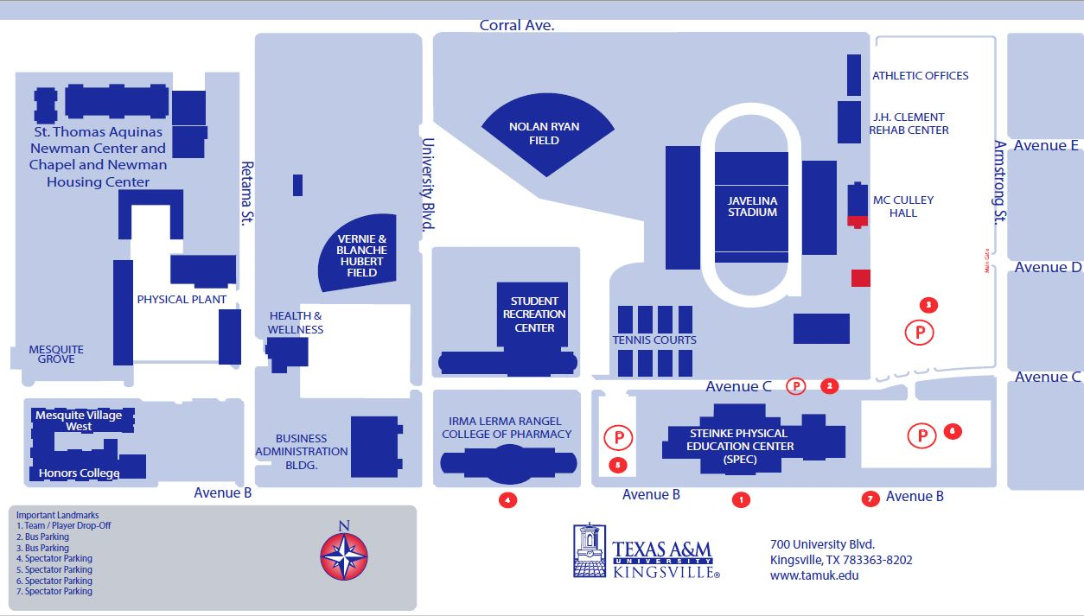

8

