UIL REGION III-4A and REGION IV-1A
TRACK & FIELD CHAMPIONSHIPS
SCHEDULE OF EVENTS
APRIL 27-28, 2018

COACHES MEETING and PACKET PICKUP: Thursday, April 26-8:00 pm
Team Meeting Room (2nd floor) of the Mafrige Field House
FRIDAY, APRIL 27, 2018
IMPLEMENT WEIGH-IN: At the athlete check in venue outside the north entrance to Bowers Stadium according to the following times:
Session #1: 6:30 to 7:30 am (4A Boys Discus)
Session #2: 9:00 to 10:00 am (4A Girls Discus)
Session #3: 11:30 to 12:30 pm (1A Girls Discus)
Session #4: 2:00 to 3:00 pm (1A Boys Discus)
FIELD EVENTS FRIDAY: Awards immediately following the completion of the event final.
1A BOYS POLE VAULT WEIGH IN: 6:45 at event site
4A BOYS POLE VAULT WEIGH IN: 9:15 am at event site
1A GIRLS POLE VAULT WEIGH IN: 11:45 am at event site
4A GIRLS POLE VAULT WEIGH IN: 2:15 pm at event site

FIELD EVENTS – FRIDAY
SESSION -- # 1  8:00 am  1A Boys Long Jump  4A Girls Long Jump  1A Girls High Jump  4ABoys Discus  1A Boys Pole Vault | SESSION -- # 2  10:30 am  4A Girls Discus  4A Boys Pole Vault  4A Boys Long Jump  1A Girls Long Jump 4A Girls High Jump | SESSION -- # 3  1:00 pm  1A Girls Discus  4A Boys Triple Jump  1A Girls Triple Jump  1A Boys High Jump  1A Girls PV | SESSION -- # 4  3:30 pm  4A Girls Pole Vault  1A Boys Triple Jump  4A Girls Triple Jump  4A Boys High Jump  1A Boys Discus

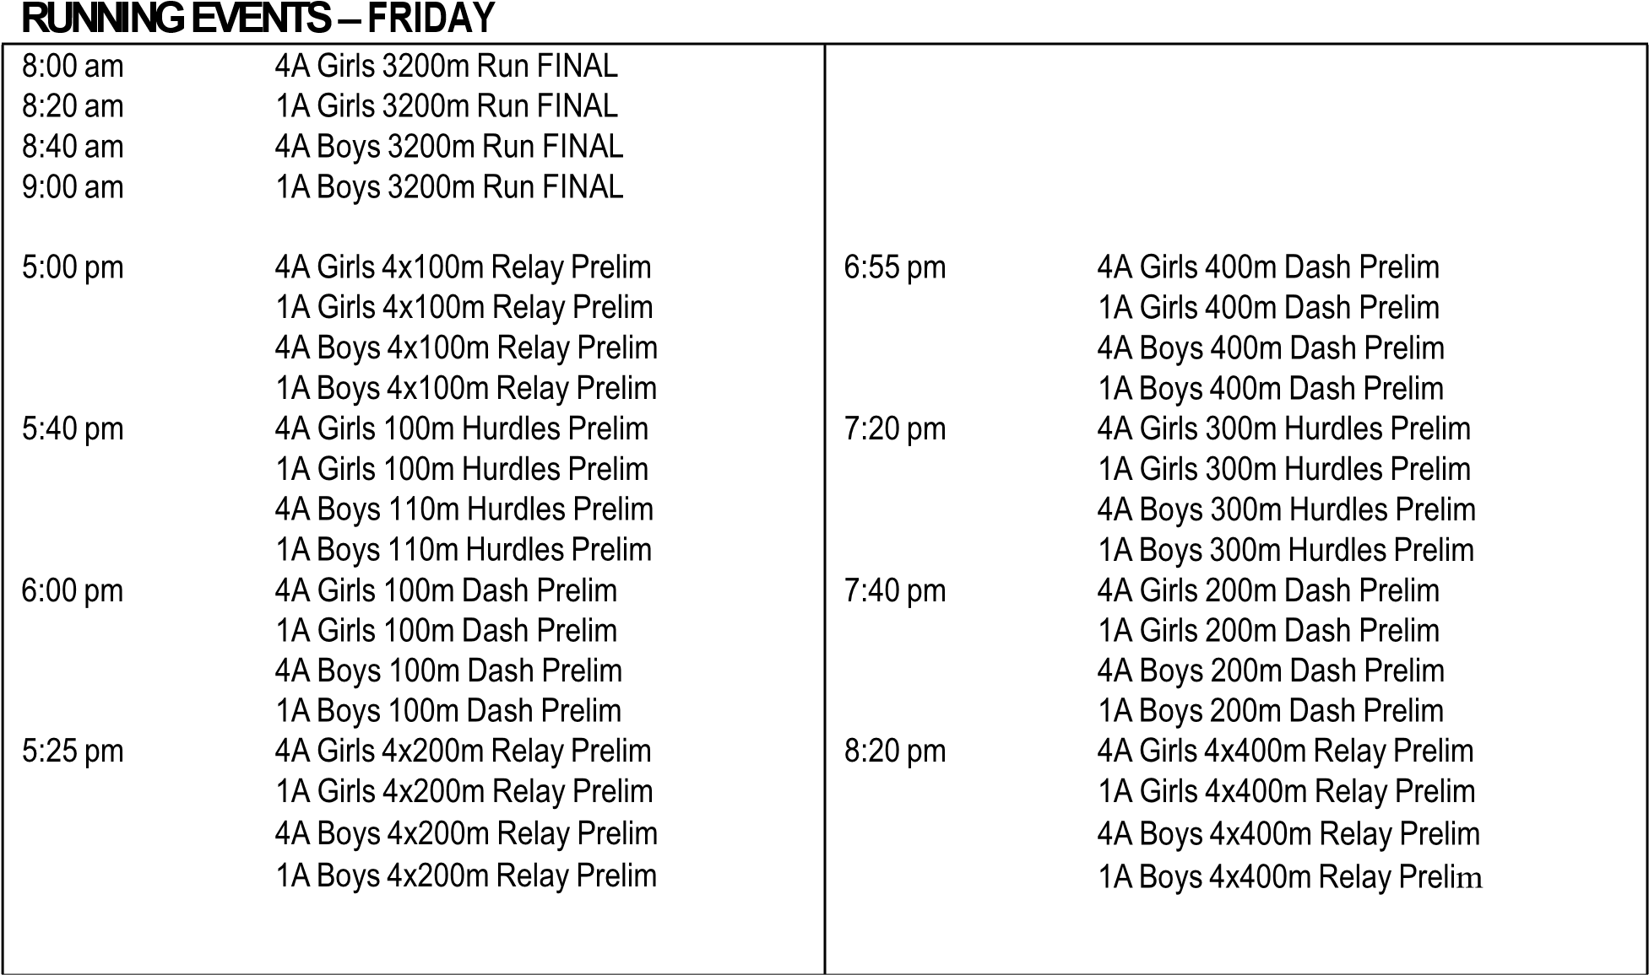
UIL REGION III-4A and REGION IV-1A
TRACK & FIELD CHAMPIONSHIPS
SCHEDULE OF EVENTS
APRIL 28-29, 2017

SATURDAY, APRIL 28:

IMPLEMENT WEIGH-IN: At the athlete check in venue outside the north entrance to Bowers Stadium according to the following times:
Session #1: 6:30 to 7:30 am (1A Girls Shot Put)
Session #2: 9:00 to 10:00 am (4A Boys Shot Put)
Session #3: 11:30 to 12:30 pm (1A Boys Shot Put)
Session #4: 2:00 to 3:00 pm (4A Girls Shot Put)
Awards immediately following the completion of the event final.

FIELD EVENTS – SATURDAY
SESSION -- # 1  8:00 am  1A Girls Shot Put | SESSION -- # 2  10:30 am  4A Boys Shot Put | SESSION -- # 3  1:00 pm  1A Boys Shot Put | SESSION -- # 4  3:30 pm  4A Girls Shot Put

