

U.I.L. One-Act Play Bi-District Contest

Conference AAAA

Region 2

Area 1

Bi-District A

Districts 9 & 10

March 11, 2018

Dear Colleagues,

On behalf of everyone at Wilmer Hutchins High School, we welcome you to our campus. We are excited about hosting the one-act play contest, and we are looking forward to making this a positive educational opportunity for all.  If there is anything we can do to help make this an enjoyable experience for your company and your school, please let us know.  We will do everything in our power to make this contest a wonderful and memorable event.

We have enclosed an informational packet detailing everything from schedules for rehearsals and contest to the stage dimensions and lighting packets.  We have provided opportunities for your school to pre-program light cues prior to the official rehearsal period in an effort to make the contest day less stressful.

Again, we welcome your school and company to share this special time. If we can answer any questions, feel free to call.

Sincerely,

Carla Ford-Rich, Contest Manager 972-935-7348  
Russell Hyland, Wilmer Hutchins High School 469-826-8034

**UIL One-Act Play District Contest General Information**

**Location of Contest** Wilmer Hutchins High School

5520 Langdon Road

Dallas, TX 75241

**Contest Date** Friday March 23, 2018

**Rehearsal Dates** Thursday March 22, 2018

Friday, March 23, 2018

**Contest Manager** Carla Ford-Rich

1700 East 15th Street

Plano, Tx 75074

972-935-7348 Cfordrich@yahoo.com

**Contest Hosts** Russell Hyland, Director of Theatre

Telephone: 972-925-2900 (main office)

**Emails:** [rhyland@dallasisd.org](mailto:rhyland@dallasisd.org)

**Administrative Contact** Mr, Campbell, Principal

Telephone: 972-925-2900

Email: JCampbell@dallasisd.org

**Critic Judge Allana Patterson**

2806 Manchester Ln.

Grapevine, TX 76051

**Wendy Barrett**

4110 Waverly Rd.

Corinth, TX 76208

**Mildred Peveto**

601 Chateau Ct.

Denton TX 76208

**Scripts** Scripts should be sent directly to judge ***NOW***

**PLEASE MAKE SURE THE SCRIPTS ARE CLEARLY MARKER AND HIGHLIGHTED. REMEMBER, NO PHOTOCOPIES.**

**District Rehearsal Schedule**

|  |  |  |
| --- | --- | --- |
| School | Load-In | Rehearsal |
| **Thursday, March 22, 2018** | | |
| 10B Wilmer Hutchins High School | 5:00-5:15 pm  She Kills Monsters | 5:30-6:30 pm |
| 10A Carter High School | 6:00.-6:15 pm  Intimate Apparel | 6:30-7:30 pm |
| 10C Uplift North Hills Prep. | 7:00-7:15 pm  Voices from the Shore | 7:30-8:30 pm |

|  |  |  |
| --- | --- | --- |
| School | Load-In | Rehearsal |
| **Friday, March 23, 2018** | | |
| 9A Frisco Lebanon Trail | 7:45-8:00 am  The Book of Everything | 8:00 -9:00 |
| 9C Sanger HS | 8:45-9:00 am  The Marriage of Bette and Boo | 9:00-10:00 |
| 9B Gainesville | 9:45-10:00 am  Maelstrom | 10:00-11:00 |

**District Performance Schedule**

|  |  |  |
| --- | --- | --- |
| SCHOOL  Order chosen by Blind Draw |  | Performance (the first performance will begin on time. All other performance times have been estimated). |
| **Friday, March 23, 2018** | | |
| **Rehearsals** | 7:45 | Until 11:00 am |
| **Director’s Meeting** | 11:30-12:00 |  |
| **Lunch** | 12:00-12:30 |  |
| **9A** | Set Up 12:50 | 1:00 |
| **9C** |  | 2:00 |
| **10A** |  | 3:00 |
| **10B** |  | 4:00 |
| **9B** |  | 5:00 |
| **10C** |  | 6:00 |
| **AWARDS** |  | 7:00 |
| **CRITIQUES** |  | 8:00 |

**Director’s Meeting:**Gallery

**11:30 a.m.**

**Performances will begin at 10:00 a.m. and will run back-to-back.**

**Lunch will be around 12:00 for 30 minutes, then we will begin again.**

**Awards will begin around 6:00 p.m.  Critiques will follow awards**

**Program Info**

Please email your program information to Cassandra Robertson at

[casrobertson@dallasisd.org](mailto:casrobertson@dallasisd.org) **no later than NOON March 13** and COPY CARLA at [cfordrich@yahoo.com](mailto:cfordrich@yahoo.com) . Remember to add Name of Play, Author, Publishing/Royalty Company (ie like Samuel French, Inc.), Location and Time Period. Also, add all your Cast, Crew and Alternates. **REMINDER: IF YOU NEED TO MAKE CHANGES PRIOR TO 10 DAYS BEFORE CONTEST, CONTACT CASSANDRA AND CARLA.**

**Unloading**

Schools will unload equipment/scenery at the bay door of the shop which is on the Langdon parking lot side. Companies should report to unload all scenery, and costumes at least 30 minutes prior to the scheduled rehearsal time.  The contest manager will meet you and your company in the Auditorium. Please have the following documents ready:

Standards and Compliance Form signed by the principal

Approval for set additions

Approval for any play not on the approved list

Evidence of royalty payment/approval for cutting

Integrity Scripts (2) Make sure they are clearly marked. YOU MAY NOT REHEARSE WITHOUT THESE

Incidental music log YOU MAY NOT REHEARSE WITHOUT THIS.

Any substitutions you may have. The form is on line.

Checks have to be made out to Visual and Performing Art Department $150.00. Fine arts should send out the invoices.

**Rehearsals**

The official rehearsal time will begin when your group enters the actual stage space (designated by the contest manager).  Each group will have one hour to rehearse.  ***Groups will need to remove and store scenery in an assigned space (as well as strike and spike entire set) by the end of the official rehearsal time.***  Any items too large to store in the assigned space will be stored in or near the scene shop (directly behind the stage).  Companies will need to strike to the loading dock at the end of the performance (no exceptions). A tour of the school and backstage facilities will follow each rehearsal period.

**The Stage**

The stage at Wilmer Hutchins is 35’ wide at the proscenium and 21’ deep (from the back wall to the curtain line).  The apron extends 11’ beyond the proscenium wall (making the total depth of the stage 32.  You will set with the curtain closed. Remember, the director or stage crew are the only ones who can set things in front of the curtain.

**Scenery**

The basic U.I.L. unit set will be available for your use and located On stage across the back wall. Door Units will be provided. If doors, what kind? (If you are using windows, you will need to bring those items.  However, all unit set pieces must be available prior to the first rehearsal.  Please make arrangements to deliver any additional set pieces to the school before the first scheduled rehearsal. All scenery is subject to the full-disclosure policy and should be in accordance with your approved ground plan.) The following unit set pieces will be available to your school.

4 – Three-fold flat units

4 – Two-fold flat units

2 – 4’-0” wide step units

2 – 2’-0” wide step units

2 – 4’-0” high pylon units

2 – 6’-0” high pylon units

2 – 8’-0” high pylon units

2 – 4’ x 4’ ramps

2 – 4’ x 4’ platforms

2 – 4’ x 8’ platforms

4 – 1’ x 1’ cubes

1 – door unit

1 – French door unit

**Sound**

We strongly suggest that you bring your own sound system. Our Sound System , a Tascam CD 200I cd player, USB  port no cassette players a .CD player Ipod dock but old. And a auxiliary import plug

**Light Board and Lighting**

Areas: 20 general lighting areas

Washes: color washes (blue, red)

Board: ETC Element Lighting Console

Cues may be run manually.

*A lighting technician from the host school will be available to assist you during rehearsal to program and alter pre-programmed cues. The technician will also be in the booth during performance, but will not be able to assist your board operator. The board does have a manual two-scene pre-set function. We will have someone in the booth.

***\*\*****It is strongly suggested that you take advantage of having your light cues pre-programmed. It will assist your school in having plenty of time for your rehearsal.*

**Curtains**

Grand Drape is drawn.

Legs: We have 3 legs. That are fixed.  The second leg back is a traveler and may be set or closed. (6’ from curtain line)

Black: The back of the stage will be closed off with a black curtain or cyc 19’  depth.

Grand drape = 0”

First leg from Grand Drape= 4’

Mid traveler/ second leg = 6’

Third leg 4’

Fourth leg = 6’

Back traveler / Cyc= 1’

**ALL THESE MEASUREMENTS SHOULD BE FROM GRAND DRAPE**

**Storage**

Storage space (approx. 7x5 square areas) will be assigned to each company. Expect to store set pieces/props on back hall.  Pieces that will not fit in storage space can be stored in or near the theatre

**Dressing Rooms**

Each company will be assigned a classroom during the duration of the competition. *Please* remember the dressing rooms are classrooms and do not contain mirrors; therefore, you must provide your own. As a courtesy to the classroom teachers, *please* leave the room exactly as you find it. Companies must strike all materials from dressing rooms prior to the Awards Ceremony

**Awards**

Awards will be as follows:

* Three Advancing Plays
* One Alternate
* Best Actor
* Best Actress
* Eight All-Star Cast
* Eight Honorable Mention
* Best Technician from each company
* Best Technical Crew

**Critiques**

Critiques order will be discussed at the director’s meeting and likely determined by distance. Schools with the furthest distance from the host school will be critiqued first. Advancing schools will be critiqued last.

**Audience Reminders**

There will be a $5.00 Ticket fee for all who are visitors to the auditorium. Contestants and Directors will have some sort of indication that they are part of the competition.

All visitors and observers of the contest should park on the Langdon Road side or at the Football stadium next to the school

All cellular telephones and any other noise-making devices must be turned off during all performances. **REMEMBER, CELL PHONES ARE NOT TO BE USED BACKSTAGE UNLESS THEY ARE A PROP AND THEN THEY MUST BE IN AIRPLANE MODE.**

*No* food or drink is allowed in the auditorium for any reason.

Please remind friends and family that no photography or recording will be allowed in the theatre during performances.

**Latecomers will be seated during performances**

**Unloading/Bus Parking**

**Parking**

Upon arrival, busses may drop off cast and crew members at the loading dock Trucks may pull into the loading dock for unloading. All busses and trucks should park Stadium parking lot

**\*\*\*\*\*ENTRANCE/ TICKET FEE\*\*\*\*\***

*Please tell your parents and others.*

In order to assist with the cost of running this contest, there will be a Ticket Fee at the door for all Visitors. The fee will be $5.00. They will receive a sticker to wear on your clothing. Cast and Crew Members will not pay.

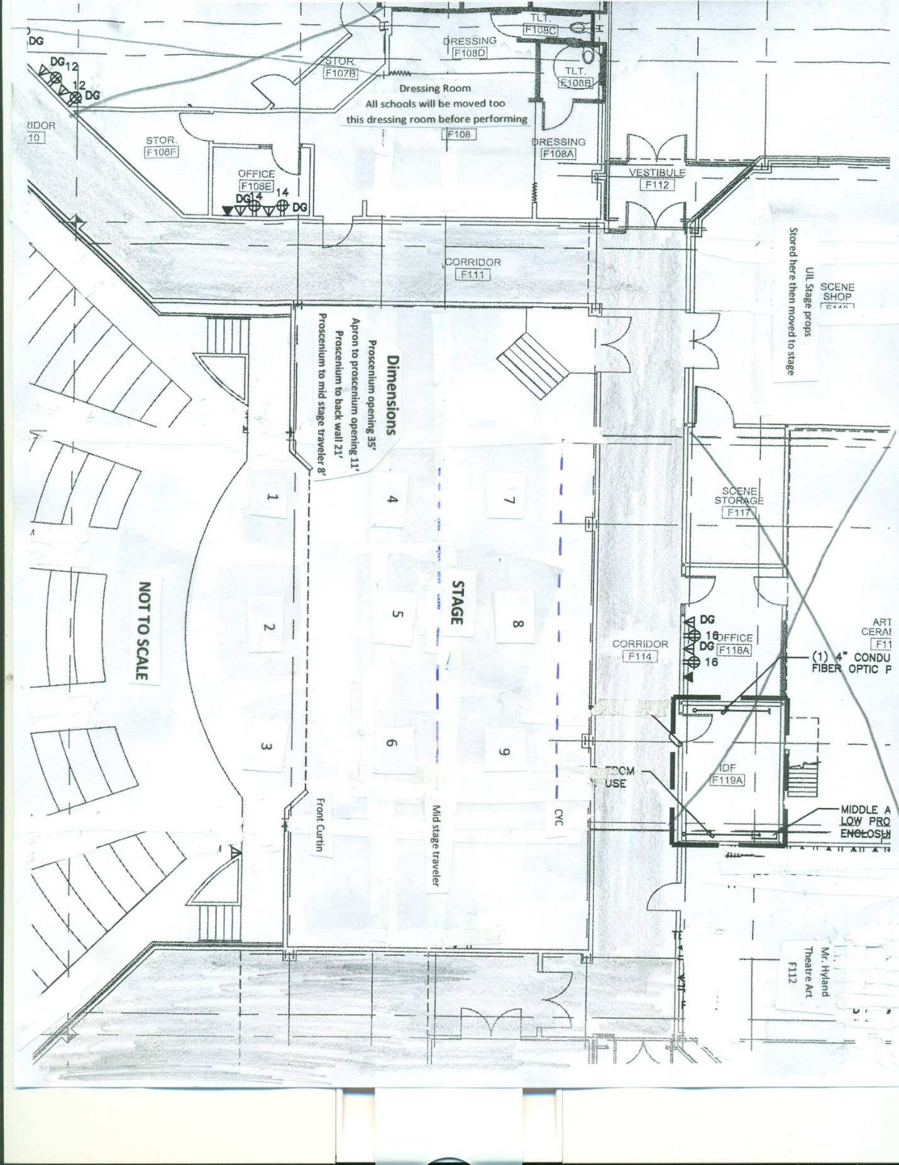

.



If you don’t like this form, there is another one in the UIL Handbook that you may prefer.

**Dates and Reminders**:

**March 13 by noon** Send Casandra Robertson and me a copy of your program information

**March 16 by noon** Send lighting cues to Russell Hyland if you want them preprogramed. If you choose not to do so, please email and let him know.

**ASAP** Enter your advancement on the UIL Website with your Cast and Crew Make sure that you do the final step which is set to send the Contest Manager a copy.

**Day of Rehearsal: MAKE SURE YOU HAVE THE FOLLOWING ITEMS TO SHOW THE CONTEST MANAGER:**

_____Standards and Compliance Form signed by the principal

_____Approval for set additions

_____Approval for any play not on the approved list

_____Evidence of royalty payment/approval for cutting

_____**Integrity Scripts (2) Make sure they are clearly marked. YOU MAY NOT REHEARSE WITHOUT THESE**

_____Incidental music log **YOU MAY NOT REHEARSE WITHOUT**

**THIS.**

_____Any substitutions you may have. The form is on line.

_____Entry Fee

Please make sure you have read and studied the entire UIL Handbook. The last thing anyone wishes to have happen is a disqualification or a negative experience at this competition.

We are here to help you. Remember, there are no dumb questions.