Schedule: Director’s Meeting will be held Monday, April 22 @ 5:00 PM Via ZOOM

Official Rehearsal: Tuesday, April 23, 2024
Time | School
7:00 -8:00 AM | Area 1 - A
8:05-9:05 AM | Area 1-C
9:10-10:10 AM | Area 2 - B
10:15-11:15 AM | Area 2-C
11:20-12:20 PM | Area 1 - B
12:25-1:25 PM | Area 2 - A

Contest Day: Thursday, April 23, 2024 -Plays will run back-to-back with no intermission. Performance order was determined by blind draw.
Time | School
2:00 PM | Area 1 - A
 | Area 1 - C
 | Area 2 - B
 | Area 2- C
 | Area 1- B
 | Area 2 - A
7:30* estimate | Critiques
8:00 PM estimate | Awards

Contest Manager :Eric Pinon – eric.pinon@austinisd.org 512-853-0109 (cell - text or call)
Host Contact Tasha Jones Tasha.jones@ccisd.us
Contest Site: Veterans Memorial High School 3750 Cimarron Blvd, Corpus Christi, TX 78414

Adjudicators:
Alison Frost  509 Coral Pl  Corpus Christi TX, 78411 | Paul Davis  26 Lenox Street  Houston Texas, 77011 | Pam Willson  2023 Sherbrook Park Ln,  Katy TX, 77449

Scripts: Please mail your scripts (not a xerox copy) to all three adjudicators as soon as possible! Please do NOT require a signature upon delivery. Make sure your school information is on the inside of the script (school, region, location). Scenes you are not using are “x-ed” out in pencil and can still be read and remaining dialogue is highlighted in yellow. Reference page 34 of the Handbook.

Mach Contest Entry Form: Use this link: https://www.uiltexas.org/machform/view.php?id=696425 - due April 17, 2024 .

Rehearsals: You will have an 50 minutes to rehearse, set light/sound cues, spike the stage, and take care of any other business that is necessary to prepare for your performance. Spike tape will be provided. Please bring the following with you to your rehearsal:
- State UIL Approval Letters
- A play approval if not on the approved list
- Permission for scenery or special properties or any written clarifications from the state UIL office.
- Proof of Royalty Payment for play (not required if within public domain)
- Publisher’s Permission to cut (not required if within public domain)
- Music Log signed and dated (can be found here)
- Integrity Script with performance text and music cues (this in in addition to the adjudicator's scripts)
- Community Standards & Copyright Compliance Form signed by your principal
- Entry Fee
- The Entry fee per school for this contest is $1,000.00. Checks should be made payable to Corpus Christi Independent School District and should be brought to the Contest Manager at the beginning of your official rehearsal. POs are not accepted. Schools will not be able to participate if a check is not received.

Program Information: An online program will be accessible via QR code and will be created using the information provided in your Mach Contest Entry Form.

Veterans Memorial HS is located at 3750 Cimarron Blvd. Corpus Christi TX 78414
All parking and building access will be in the student parking lot located on the northeast side of the building, do not park/enter at the main entrance of the school.

Loading In:
To get to the loading dock enter the student parking lot from Cimarron Blvd. and look for the dumpsters on the right-hand side of the driveway. Drive through the gate next to the dumpsters, the overhead door immediately to the left is the auditorium loading dock. Upon arrival please text (512)853-0109. Someone from the host site will meet you and your company at the loading dock.

Facility:
- Com stations are located on both sides of the stage and two in the control booth. You are welcome to bring your own headset with a standard Clear-Com, 4-pin XLR female connector.
- All curtain pulls are operated from Stage Left. Please specify to the Site Crew during your official rehearsal if you would like to have a specific leg or curtain flown in/out, or if you need assistance opening the main curtain for your performance. Only site crew can operate the fly rail for safety purposes.
- Mid-stage traveler curtain can be closed to make stage smaller, other legs do not close completely.
- Safety lights will be on backstage.
- Sandbags, and traditional Stage Weights are available upon request.
- Spike tape will be provided.
- A floor plan with dimensions, and power locations is attached.
- A holding room (classroom) will be provided for your company to use throughout the contest (April 23, 2024). Please be advised that this is a regular school day and Veterans students will be transitioning from their classes so company members must remain in their rooms at all times unless using the restrooms, or watching performances.

Lighting:
- Please see the attached lighting plot.
- The stage is lit in four rows of five areas: twenty areas in total.
- Cyc colors- RGB/Color mixing Floor colors- RGB/Color mixing
- One follow spot is available for use in the back of the auditorium.
- Pre-programed lighting cues will not be offered for this contest, a lighting look sheet has been attached to assist you in preparation. (UNLESSS YOU SEND ERIC PINON and Burt Baxtor your light cues by April 14,2024 5:00 pm)
- The house light board is an ETC ION with a 20x20 fader wing.

Sound:
- If you wish to use our sound system, we will provide 1 CD player, or a 1/8” aux cord. If you plan to play your sound effects via aux cord, you must provide your own device. We will not have the ability to play music directly from a flash drive.
- The house sound board is a Yamaha CL3.

Unit Set: The approved UIL unit set will be available at the contest site. Also available will be two door units, one French door units, and one window units. All door and window units will have no header attached. Please do not drag the unit set during rehearsal or performance.

Site Crew: Site Crew will be present backstage, and in the booth at all times. Site Crew will be available to assist during rehearsals only. During your performance, Site Crew will only give aid in the event of equipment malfunction, or site emergency. Please contact Burton.Baxter@ccisd.us and CC eric.pinon@austinisd.org for any site related questions.

Awards: The announcement of advancing plays & the presentation of awards will follow the last performance as soon as the adjudicators have completed their decisions. Plaques will be presented to the top two plays. Individual medals will be given to Best Performers, All-Star Cast, Honorable Mention, and All-Star Crew. Excessive celebration by the students and their families (yelling, screaming) will not be permitted.

Critique: The critique is very important part of the OAP process. Please be courteous, attentive, and receptive towards the judge and other cast.

Admission to the Performance:
Admission charge will be $10.00 no late seating will be permitted. The company is reminded not to re-enter the auditorium in make-up or costume after their performance.

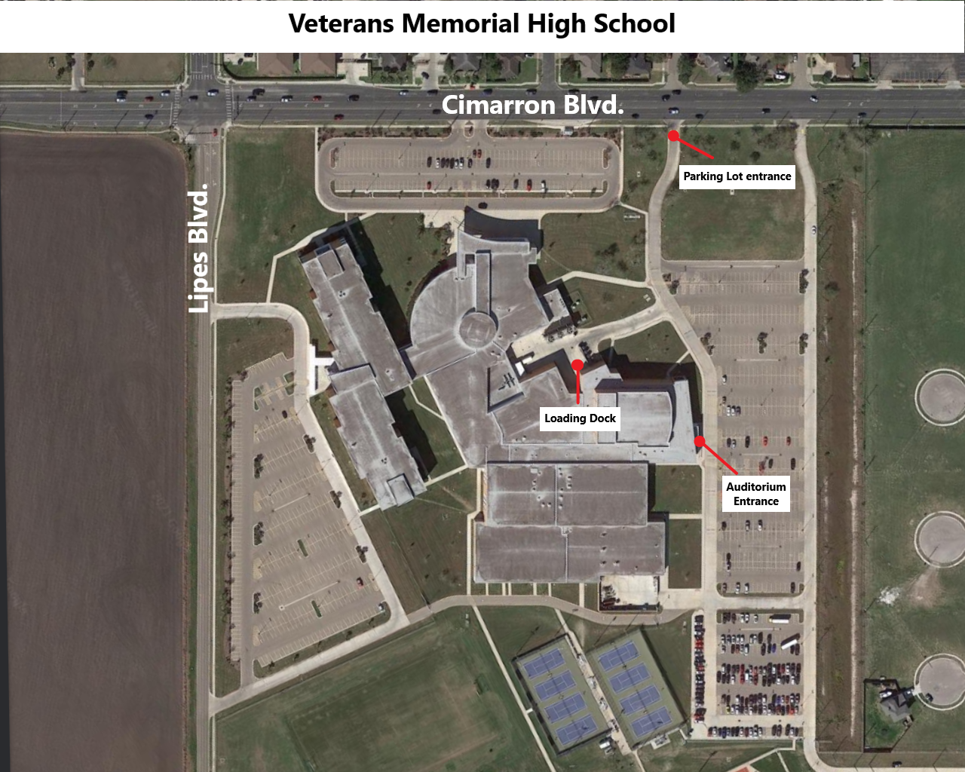
To Scene Shop/Loading Dock
≈4’
Upstage Crossover Curtain/CYC
Leg
29’
Leg
≈7’
Mid-stage Traveler Curtain
Main Traveler Curtain
11.5’
≈2’
Curtain Pull Located Offstage Left
38’
Proscenium

Proscenium
4’
Audience
**This drawing is not to scale**
Stage height is 28” above orchestra seating level
-Power outlet in floor pocket
-Power outlet on wall
20
16
17
19
18
14
15
13
11
12
8
6
7
10
9
Proscenium

Proscenium
3
1
2
4
5
Audience
CYC Colors:
RGB & Color Mixing

Floor/Overhead Colors:
RGB & Color Mixing

UIL OAP MEET

LIGHTING LOOK SHEET

Veterans Memorial High School Auditorium

Using the VMHS Light Plot, indicate the percentage of intensity for each look. Percentages should be indicated in increments of 5, from 10% to 100% or “F” (Full). For a complete Blackouts, write B/O and draw a line through all the areas. You can use the same look for multiple/repeating cues.

EXAMPLE: LOOK # A CUE # and TIME to execute cue: Cue 1, Time 3 sec
Cue 8, Time 0 sec
Cue 17, Time 5 sec

Areas |  |  |  |  |  |  |  |  |  |  |  |  |  |  |  |  |  |  |  |  | Floor Wash |  |  |  | Back/Cyc
1 | 2 | 3 | 4 | 5 | 6 | 7 | 8 | 9 | 10 | 11 | 12 | 13 | 14 | 15 | 16 | 17 | 18 | 19 | 20 20 | R |  | G | B | R |  | G | B
 |  | F |  |  |  |  | F |  |  |  | 75 | 75 |  |  |  |  |  |  |  |  |  | 75 |  |  |  | 50

LOOK #1 CUE # and TIME to execute cue: _________________________
_________________________ _________________________

Areas |  |  |  |  |  |  |  |  |  |  |  |  |  |  |  |  |  |  |  |  | Floor Wash |  |  |  | Back/Cyc
1 | 2 | 3 | 4 | 5 | 6 | 7 | 8 | 9 | 10 | 11 | 12 | 13 | 14 | 15 | 16 | 17 | 18 | 19 | 20 20 | R |  | G | B | R |  | G | B

LOOK #2 CUE # and TIME to execute cue: _________________________
_________________________ _________________________

Areas |  |  |  |  |  |  |  |  |  |  |  |  |  |  |  |  |  |  |  |  | Floor Wash |  |  |  | Back/Cyc
1 | 2 | 3 | 4 | 5 | 6 | 7 | 8 | 9 | 10 | 11 | 12 | 13 | 14 | 15 | 16 | 17 | 18 | 19 | 20 20 | R |  | G | B | R |  | G | B

LOOK #3 CUE # and TIME to execute cue: _________________________
_________________________ _________________________

Areas |  |  |  |  |  |  |  |  |  |  |  |  |  |  |  |  |  |  |  |  | Floor Wash |  |  |  | Back/Cyc
1 | 2 | 3 | 4 | 5 | 6 | 7 | 8 | 9 | 10 | 11 | 12 | 13 | 14 | 15 | 16 | 17 | 18 | 19 | 20 20 | R |  | G | B | R |  | G | B
LOOK #4 CUE # and TIME to execute cue: _________________________
_________________________ _________________________

Areas |  |  |  |  |  |  |  |  |  |  |  |  |  |  |  |  |  |  |  |  | Floor Wash |  |  |  | Back/Cyc
1 | 2 | 3 | 4 | 5 | 6 | 7 | 8 | 9 | 10 | 11 | 12 | 13 | 14 | 15 | 16 | 17 | 18 | 19 | 20 20 | R |  | G | B | R |  | G | B

LOOK #5 CUE # and TIME to execute cue: _________________________
_________________________ _________________________

Areas |  |  |  |  |  |  |  |  |  |  |  |  |  |  |  |  |  |  |  |  | Floor Wash |  |  |  | Back/Cyc
1 | 2 | 3 | 4 | 5 | 6 | 7 | 8 | 9 | 10 | 11 | 12 | 13 | 14 | 15 | 16 | 17 | 18 | 19 | 20 20 | R |  | G | B | R |  | G | B

LOOK #6 CUE # and TIME to execute cue: _________________________
_________________________ _________________________

Areas |  |  |  |  |  |  |  |  |  |  |  |  |  |  |  |  |  |  |  |  | Floor Wash |  |  |  | Back/Cyc
1 | 2 | 3 | 4 | 5 | 6 | 7 | 8 | 9 | 10 | 11 | 12 | 13 | 14 | 15 | 16 | 17 | 18 | 19 | 20 20 | R |  | G | B | R |  | G | B

LOOK #7 CUE # and TIME to execute cue: _________________________
_________________________ _________________________

Areas |  |  |  |  |  |  |  |  |  |  |  |  |  |  |  |  |  |  |  |  | Floor Wash |  |  |  | Back/Cyc
1 | 2 | 3 | 4 | 5 | 6 | 7 | 8 | 9 | 10 | 11 | 12 | 13 | 14 | 15 | 16 | 17 | 18 | 19 | 20 20 | R |  | G | B | R |  | G | B

LOOK #8 CUE # and TIME to execute cue: _________________________
_________________________ _________________________

Areas |  |  |  |  |  |  |  |  |  |  |  |  |  |  |  |  |  |  |  |  | Floor Wash |  |  |  | Back/Cyc
1 | 2 | 3 | 4 | 5 | 6 | 7 | 8 | 9 | 10 | 11 | 12 | 13 | 14 | 15 | 16 | 17 | 18 | 19 | 20 20 | R |  | G | B | R |  | G | B
LOOK #9 CUE # and TIME to execute cue: _________________________
_________________________ _________________________

Areas |  |  |  |  |  |  |  |  |  |  |  |  |  |  |  |  |  |  |  |  | Floor Wash |  |  |  | Back/Cyc
1 | 2 | 3 | 4 | 5 | 6 | 7 | 8 | 9 | 10 | 11 | 12 | 13 | 14 | 15 | 16 | 17 | 18 | 19 | 20 20 | R |  | G | B | R |  | G | B

LOOK #10 CUE # and TIME to execute cue: _________________________
_________________________ _________________________

Areas |  |  |  |  |  |  |  |  |  |  |  |  |  |  |  |  |  |  |  |  | Floor Wash |  |  |  | Back/Cyc
1 | 2 | 3 | 4 | 5 | 6 | 7 | 8 | 9 | 10 | 11 | 12 | 13 | 14 | 15 | 16 | 17 | 18 | 19 | 20 20 | R |  | G | B | R |  | G | B

LOOK #11 CUE # and TIME to execute cue: _________________________
_________________________ _________________________

Areas |  |  |  |  |  |  |  |  |  |  |  |  |  |  |  |  |  |  |  |  | Floor Wash |  |  |  | Back/Cyc
1 | 2 | 3 | 4 | 5 | 6 | 7 | 8 | 9 | 10 | 11 | 12 | 13 | 14 | 15 | 16 | 17 | 18 | 19 | 20 20 | R |  | G | B | R |  | G | B

LOOK #12 CUE # and TIME to execute cue: _________________________
_________________________ _________________________

Areas |  |  |  |  |  |  |  |  |  |  |  |  |  |  |  |  |  |  |  |  | Floor Wash |  |  |  | Back/Cyc
1 | 2 | 3 | 4 | 5 | 6 | 7 | 8 | 9 | 10 | 11 | 12 | 13 | 14 | 15 | 16 | 17 | 18 | 19 | 20 20 | R |  | G | B | R |  | G | B

LOOK #13 CUE # and TIME to execute cue: _________________________
_________________________ _________________________

Areas |  |  |  |  |  |  |  |  |  |  |  |  |  |  |  |  |  |  |  |  | Floor Wash |  |  |  | Back/Cyc
1 | 2 | 3 | 4 | 5 | 6 | 7 | 8 | 9 | 10 | 11 | 12 | 13 | 14 | 15 | 16 | 17 | 18 | 19 | 20 20 | R |  | G | B | R |  | G | B
LOOK #14 CUE # and TIME to execute cue: _________________________
_________________________ _________________________

Areas |  |  |  |  |  |  |  |  |  |  |  |  |  |  |  |  |  |  |  |  | Floor Wash |  |  |  | Back/Cyc
1 | 2 | 3 | 4 | 5 | 6 | 7 | 8 | 9 | 10 | 11 | 12 | 13 | 14 | 15 | 16 | 17 | 18 | 19 | 20 20 | R |  | G | B | R |  | G | B

LOOK #15 CUE # and TIME to execute cue: _________________________
_________________________ _________________________

Areas |  |  |  |  |  |  |  |  |  |  |  |  |  |  |  |  |  |  |  |  | Floor Wash |  |  |  | Back/Cyc
1 | 2 | 3 | 4 | 5 | 6 | 7 | 8 | 9 | 10 | 11 | 12 | 13 | 14 | 15 | 16 | 17 | 18 | 19 | 20 20 | R |  | G | B | R |  | G | B

LOOK #16 CUE # and TIME to execute cue: _________________________
_________________________ _________________________

Areas |  |  |  |  |  |  |  |  |  |  |  |  |  |  |  |  |  |  |  |  | Floor Wash |  |  |  | Back/Cyc
1 | 2 | 3 | 4 | 5 | 6 | 7 | 8 | 9 | 10 | 11 | 12 | 13 | 14 | 15 | 16 | 17 | 18 | 19 | 20 20 | R |  | G | B | R |  | G | B

LOOK #17 CUE # and TIME to execute cue: _________________________
_________________________ _________________________

Areas |  |  |  |  |  |  |  |  |  |  |  |  |  |  |  |  |  |  |  |  | Floor Wash |  |  |  | Back/Cyc
1 | 2 | 3 | 4 | 5 | 6 | 7 | 8 | 9 | 10 | 11 | 12 | 13 | 14 | 15 | 16 | 17 | 18 | 19 | 20 20 | R |  | G | B | R |  | G | B

LOOK #18 CUE # and TIME to execute cue: _________________________
_________________________ _________________________

Areas |  |  |  |  |  |  |  |  |  |  |  |  |  |  |  |  |  |  |  |  | Floor Wash |  |  |  | Back/Cyc
1 | 2 | 3 | 4 | 5 | 6 | 7 | 8 | 9 | 10 | 11 | 12 | 13 | 14 | 15 | 16 | 17 | 18 | 19 | 20 20 | R |  | G | B | R |  | G | B

LOOK #19 CUE # and TIME to execute cue: _________________________
_________________________ _________________________

Areas |  |  |  |  |  |  |  |  |  |  |  |  |  |  |  |  |  |  |  |  | Floor Wash |  |  |  | Back/Cyc
1 | 2 | 3 | 4 | 5 | 6 | 7 | 8 | 9 | 10 | 11 | 12 | 13 | 14 | 15 | 16 | 17 | 18 | 19 | 20 20 | R |  | G | B | R |  | G | B

LOOK #20 CUE # and TIME to execute cue: _________________________
_________________________ _________________________

Areas |  |  |  |  |  |  |  |  |  |  |  |  |  |  |  |  |  |  |  |  | Floor Wash |  |  |  | Back/Cyc
1 | 2 | 3 | 4 | 5 | 6 | 7 | 8 | 9 | 10 | 11 | 12 | 13 | 14 | 15 | 16 | 17 | 18 | 19 | 20 20 | R |  | G | B | R |  | G | B

Which background will you use? (Please circle one.) Cyc Solid Black Midstage Black

Will you bring additional lighting equipment [must meet limitations of 1033 (c)(2)(F)]

If yes, please describe: (Type of equipment, number of electrical outlets required, etc.)

