WYLIE HIGH SCHOOL 4502 Antilley Rd. Abilene, TX 79606
Dear Directors,
Congratulations on advancing!!! Enclosed is information pertaining to schedules, stage, lighting, and sound information. Please let us know if there is anything we can do to make your visit to Abilene an enjoyable one. The Abilene Visitors Bureau has also reached out to get special hotel rates for our visiting schools. I have included that information as well. We look forward hosting 1A Region 2 Area 2 at the Wylie Performing Arts Center. Please let us know if you have any further questions.
1A Region 2 Area 2 One Act Play Contest April 5th, 2019
Contest Manager- Christopher Shoemake
Cell: (325)436-9718 Email- cshoemake@wyliebulldogs.org

Adjudicators-
Terry Marrs- 702 Meadow Lane PO Box 308 Bronte Texas, 76933
Nicholas Ewen- P.O. Box 2354 Brownwood TX, 76804
Bernadette Egly- 12330 Vance Jackson Rd. Apt. 11102 San Antonio Texas, 78230

Please be ready to move in to the PAC 15 Minutes before your scheduled rehearsal time.

Rehearsal Times
(Thursday April 4th)
10:00am-10:50am Hermleigh
(Friday April 5th)
7:30am-8:20am Highland
8:25am-9:15am Rule
9:20am-10:10am Benjamin
10:15am-11:05am Guthrie
11:10am-12:00pm Jayton
Directors Meeting- 12:15pm in the Black Box Theatre

Performance Order
Bi-District A or B followed by play title alphabetically(ignore articles at the beginning of titles such as a and the)
1. (AB) Highland Front (1pm)
2. (BA) Benjamin The Effect of Gamma Rays on Man-in-the-Moon Marigolds
3. (AC) Hermleigh These Shining Lives
4. (BB) Guthrie The Last Night of Ballyhoo
5. (AA) Rule The Cover of LIFE
6. (BC) Jayton These Shining Lives
Shows will run back to back
ELIGIBILITY NOTICE
Eligibility information is all online. Be sure and check that all of your information has been correctly verified. And since time is short, and since the download of student information from the UIL website is in alphabetical order instead of “in order of appearance,” please email a word document of your program information to cshoemake@wylie.esc14.net
The program will be 4X8 ….. Please send it in Word Do not put in any periods, dots- anything between the character name and student’s name.
School
Title
Author
Setting (time and location if necessary)
Cast
Character Name Name of Student
Crew
Alternates
Director(s) Name(s)
Publisher
Music Credit – if needed

JUDGE’S SCRIPTS and INTEGRITY SCRIPT
Please send a copy of your script to the critic judges at the address above.
- Do not send a Xerox copy. The script will be returned.
- Make sure the scenes you are not using are “x-ed” out in black and that the remaining dialogue is
highlighted in yellow.
- Do not require the judge’s signature for delivery.
REQUIRED DOCUMENTATION
Have the following ready to present to the Contest Manager at your rehearsal:
• Proof of Royalty Payment, Publisher’s Permission to Cut, And State UIL Approval Letters: This includes documentation required for your performance such as permission for cutting long plays, play approval if the play is not on the approved list, letters of permission for additional scenery or any written clarifications from the State UIL office.
- Community Standards and Copyright Compliance Form
- Integrity Script and Music Cue Log: (Due at Rehearsal) Present a copy of the approved published original script, in addition to the one you have provided for the judge, marked to reflect the exact performance text being used. Prepare a music cue log sheet of incidental sound/music, noted in the script showing the duration of each cue and the cumulative total.
Technical Information
We have 15 lighted acting areas, a red, blue green and amber wash, and red, blue, green, and amber cyc colors.
Our Light Board is an ETC. Ion with all areas, color washes, and cyc colors on submasters. Our sound board is a Yamaha QL5 and is capable of running just about any device with an auxiliary cable. We can use CD, Ipad, Laptop etc. If you have any questions regarding our sound or lighting system please let me know.
We have the following Unit Set pieces:
2- 4x8 platforms, 2- 4x4 Platforms, 2- 4 foot ramps, 2- 4 foot Step Units, 2- 2 foot step Units, 4- 1 foot cubes, 2- 4 foot pylons, 2- 6 foot pylons, 2- 8 foot pylons, 4- Bi-fold Flats, 4- Tri-fold flats, 2- Interior Door Units, 1- Window Unit. When you arrive pull into the parking lot located behind the PAC. (past the High School)
There is a utility driveway that leads to the Theatre loading Dock door. This will be where you need to unload. After you have unloaded, buses will need to park in the back parking lot, by the softball field. After 4pm buses may park in front of the PAC.
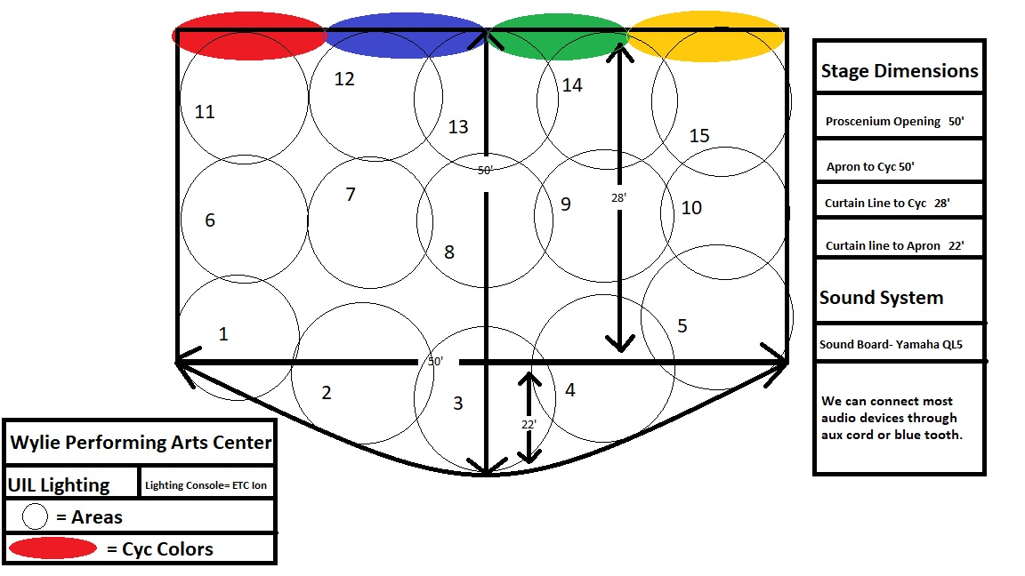

1101 N. 1st St. • Abilene, TX 79601
325-676-2556 • 800-727-7704
www.abilenevisitors.com

UIL
1A One Act Play
April 4-5, 2019

The following properties offer special rates and room blocks with a signed contract.
Hotel | Block | Rate | Amenities
Candlewood Suites *  3050 Catclaw Dr. | 325-437-4741  Christi Hanks – Director of Sales | 30 | $89 Flat Rate  Plus Tax | Outdoor pool Continental breakfast Six wheelchair accessible rooms, all with roll-in showers
Courtyard by Marriott NE *  2101 Scottish Dr. | 325-673-0400  Kady Bullock – Sales Manger | 10 | $109 Single  $119 Double  Plus Tax | Restaurant Lounge Outdoor pool Shares lobby with TownePlace Suites NE
Courtyard by Marriott Mall South *  4350 Ridgemont Dr. | 325-695-9600  Sylvia Holcomb – Sales Manager | 15 | $99 Flat Rate  Plus Tax | Restaurant Lounge Outdoor pool Five wheelchair accessible rooms, two with roll-in showers
Holiday Inn Abilene – North College Area *  3525 West Lake Road | 325-673-1400  Casey Taylor – Sales  *Breakfast included | 30 | $99 Flat Rate  Plus Tax | Restaurant Lounge Outdoor pool 18 wheelchair accessible rooms
LaQuinta Inn & Suites *  3018 Catclaw Dr. | 325-437-4832  Christi Hanks – Director of Sales | 30 | $99 Flat Rate  Plus Tax | Outdoor pool Hot breakfast Six wheelchair accessible rooms one with a roll-in shower
Residence Inn *  1641 Musgrave Trail | 325-677-8700  Sylvia Holcomb – Sales Manager | 15 | $99 Flat Rate  Plus Tax | Outdoor pool Hot breakfast  Evening meal four nights a week  Two wheelchair accessible rooms, both with roll-in showers
Whitten Inn University *  1625 Hwy. 351 | 325-673-5271  Stephanie O’Neal - Sales | 30 | $69 Flat Rate  Plus Tax | Outdoor pool Continental breakfast Two wheelchair accessible rooms, one with a roll-in shower
* Free wireless internet throughout property.
All properties listed have free parking.

