UIL LIGHTING INSTRUCTIONS
Raymond E. Hartfield PERFORMING ARTS CENTER

The UIL lighting in the Raymond E. Hartfield PAC consists of fifteen (15) areas, (each approximately 9’ X 9’), each illuminated by two front lights and one down light.
Each down light has the ability to color mix utilizing red, green and blue values. There is also a cyc that has the ability to color mix utilizing red, green and blue values. Participants have the option of not using the cyc and using a full upstage blackout drop.
There is one follow spot provided, but its use should be specially requested. There is NO limit to looks or Light Q’s.
Please complete and return the attached lighting cue sheet and questionnaire by the deadline, THURSDAY, April 28 BY 5PM, in order to facilitate your lighting needs.
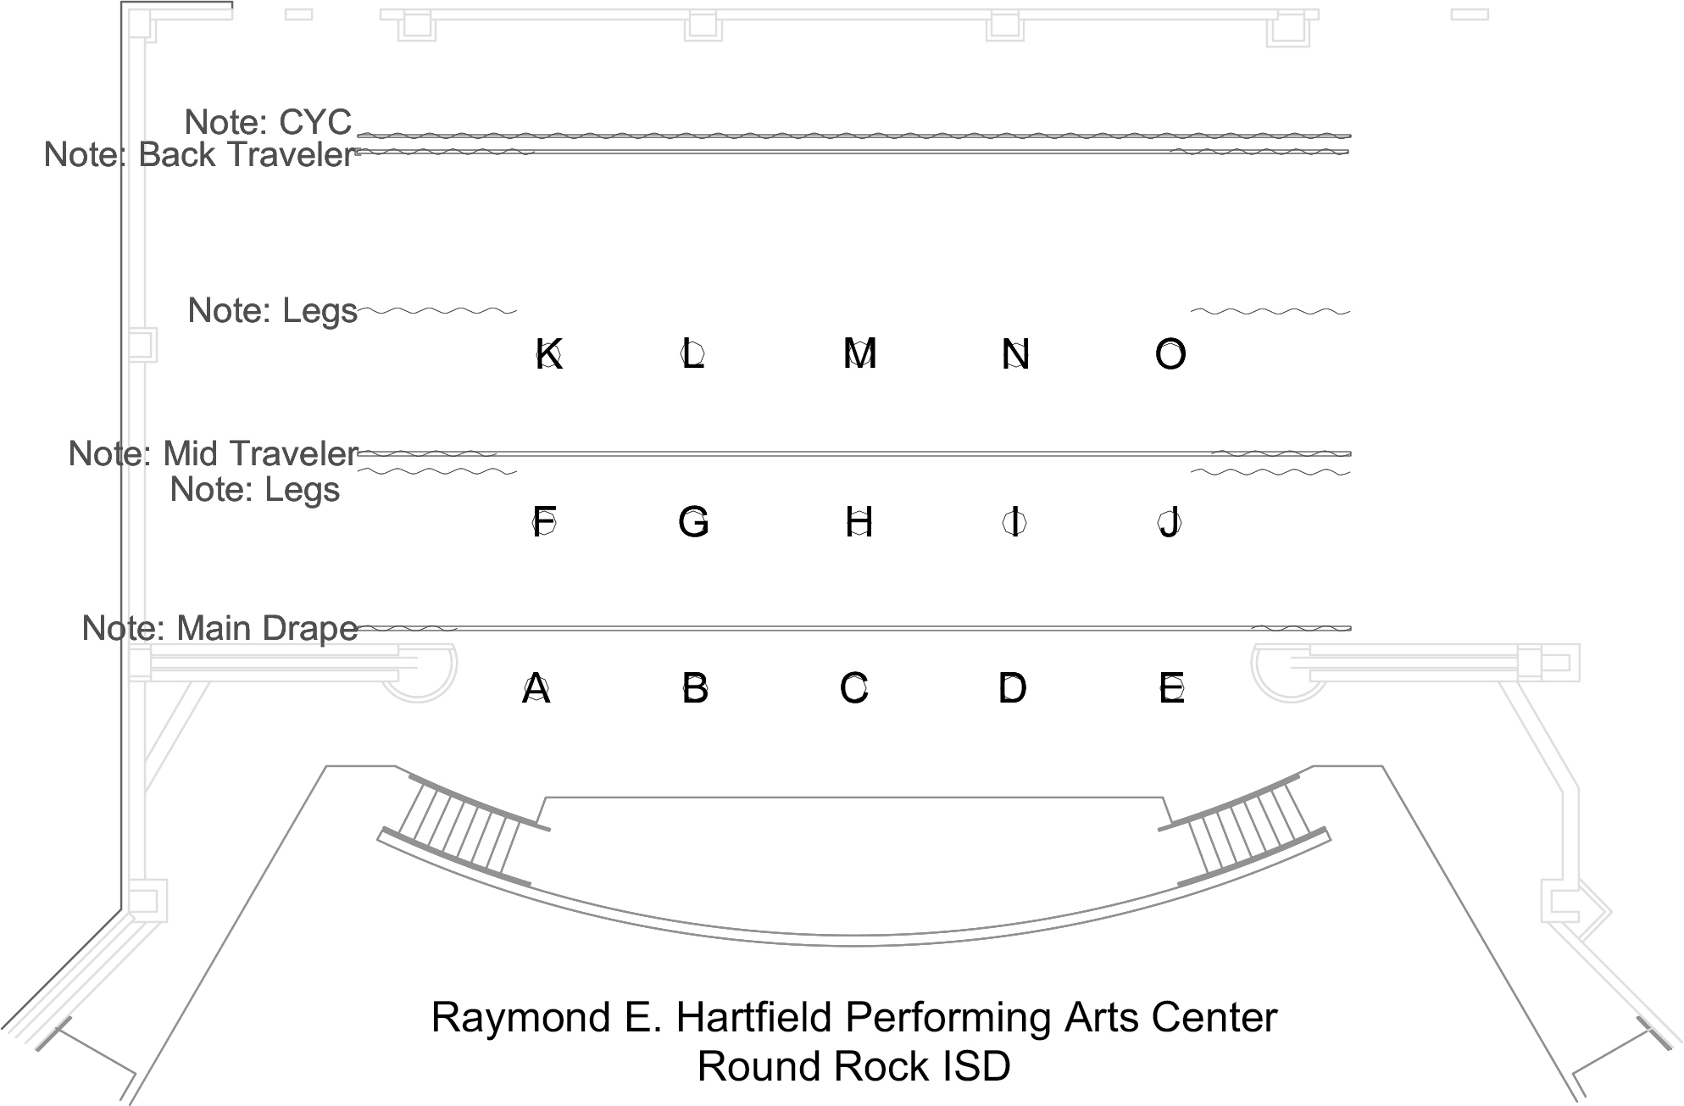

Using the diagram on the first page, indicate the percentage of intensity for each look. For areas you can give a separate level for the downlight and the front lights Percentages should be indicated in increments of 5, from 10% to 100% or F (Full).
For the cyc you can give a name of a color in lieu of specific percentages if you wish.
There are no look limits. Print extra pages as needed.

EXAMPLE: LOOK # 1

Areas |  |  |  |  |  |  |  |  |  |  |  |  |  |  |  | Cyc
 | 1 | 2 | 3 | 4 | 5 | 6 | 7 | 8 | 9 | 10 | 11 | 12 | 13 | 14 | 15 | R | G | B
Fronts | 80 | 75 | 80 | 80 |  | 50 | 60 |  |  |  | 20 | 15 | 90 | F
Down Red | 20 | 20 | 20 | 20 |  | 20 |  |  |  |  | 35 | 20 | 20 |  |  | Color  Lt. Blue-Green
Down Green | 65 |  | 65 | 65 |  |  |  |  |  |  | 35 |  |  | 40
Down Blue | 35 | 20 | 35 | 35 |  | 20 | 65 |  |  |  | 35 | 20 | 20 | F

Areas |  |  |  |  |  |  |  |  |  |  |  |  |  |  |  | Cyc
 | 1 | 2 | 3 | 4 | 5 | 6 | 7 | 8 | 9 | 10 | 11 | 12 | 13 | 14 | 15 | R | G | B
Fronts
Down Red |  |  |  |  |  |  |  |  |  |  |  |  |  |  |  | Color
Down Green
Down Blue

LOOK #:

Areas |  |  |  |  |  |  |  |  |  |  |  |  |  |  |  | Cyc
 | 1 | 2 | 3 | 4 | 5 | 6 | 7 | 8 | 9 | 10 | 11 | 12 | 13 | 14 | 15 | R | G | B
Fronts
Down Red |  |  |  |  |  |  |  |  |  |  |  |  |  |  |  | Color
Down Green
Down Blue

LOOK #:

Areas |  |  |  |  |  |  |  |  |  |  |  |  |  |  |  | Cyc
 | 1 | 2 | 3 | 4 | 5 | 6 | 7 | 8 | 9 | 10 | 11 | 12 | 13 | 14 | 15 | R | G | B
Fronts
Down Red |  |  |  |  |  |  |  |  |  |  |  |  |  |  |  | Color
Down Green
Down Blue

Areas |  |  |  |  |  |  |  |  |  |  |  |  |  |  |  | Cyc
 | 1 | 2 | 3 | 4 | 5 | 6 | 7 | 8 | 9 | 10 | 11 | 12 | 13 | 14 | 15 | R | G | B
Fronts
Down Red |  |  |  |  |  |  |  |  |  |  |  |  |  |  |  | Color
Down Green
Down Blue

LOOK #:

Areas |  |  |  |  |  |  |  |  |  |  |  |  |  |  |  | Cyc
 | 1 | 2 | 3 | 4 | 5 | 6 | 7 | 8 | 9 | 10 | 11 | 12 | 13 | 14 | 15 | R | G | B
Fronts
Down Red |  |  |  |  |  |  |  |  |  |  |  |  |  |  |  | Color
Down Green
Down Blue

LOOK #:

Areas |  |  |  |  |  |  |  |  |  |  |  |  |  |  |  | Cyc
 | 1 | 2 | 3 | 4 | 5 | 6 | 7 | 8 | 9 | 10 | 11 | 12 | 13 | 14 | 15 | R | G | B
Fronts
Down Red |  |  |  |  |  |  |  |  |  |  |  |  |  |  |  | Color
Down Green
Down Blue

Areas |  |  |  |  |  |  |  |  |  |  |  |  |  |  |  | Cyc
 | 1 | 2 | 3 | 4 | 5 | 6 | 7 | 8 | 9 | 10 | 11 | 12 | 13 | 14 | 15 | R | G | B
Fronts
Down Red |  |  |  |  |  |  |  |  |  |  |  |  |  |  |  | Color
Down Green
Down Blue

LOOK #:

Areas |  |  |  |  |  |  |  |  |  |  |  |  |  |  |  | Cyc
 | 1 | 2 | 3 | 4 | 5 | 6 | 7 | 8 | 9 | 10 | 11 | 12 | 13 | 14 | 15 | R | G | B
Fronts
Down Red |  |  |  |  |  |  |  |  |  |  |  |  |  |  |  | Color
Down Green
Down Blue

LOOK #:

Areas |  |  |  |  |  |  |  |  |  |  |  |  |  |  |  | Cyc
 | 1 | 2 | 3 | 4 | 5 | 6 | 7 | 8 | 9 | 10 | 11 | 12 | 13 | 14 | 15 | R | G | B
Fronts
Down Red |  |  |  |  |  |  |  |  |  |  |  |  |  |  |  | Color
Down Green
Down Blue

Areas |  |  |  |  |  |  |  |  |  |  |  |  |  |  |  | Cyc
 | 1 | 2 | 3 | 4 | 5 | 6 | 7 | 8 | 9 | 10 | 11 | 12 | 13 | 14 | 15 | R | G | B
Fronts
Down Red |  |  |  |  |  |  |  |  |  |  |  |  |  |  |  | Color
Down Green
Down Blue

LOOK #:

Areas |  |  |  |  |  |  |  |  |  |  |  |  |  |  |  | Cyc
 | 1 | 2 | 3 | 4 | 5 | 6 | 7 | 8 | 9 | 10 | 11 | 12 | 13 | 14 | 15 | R | G | B
Fronts
Down Red |  |  |  |  |  |  |  |  |  |  |  |  |  |  |  | Color
Down Green
Down Blue

LOOK #:

Areas |  |  |  |  |  |  |  |  |  |  |  |  |  |  |  | Cyc
 | 1 | 2 | 3 | 4 | 5 | 6 | 7 | 8 | 9 | 10 | 11 | 12 | 13 | 14 | 15 | R | G | B
Fronts
Down Red |  |  |  |  |  |  |  |  |  |  |  |  |  |  |  | Color
Down Green
Down Blue

Areas |  |  |  |  |  |  |  |  |  |  |  |  |  |  |  | Cyc
 | 1 | 2 | 3 | 4 | 5 | 6 | 7 | 8 | 9 | 10 | 11 | 12 | 13 | 14 | 15 | R | G | B
Fronts
Down Red |  |  |  |  |  |  |  |  |  |  |  |  |  |  |  | Color
Down Green
Down Blue

LOOK #:

Areas |  |  |  |  |  |  |  |  |  |  |  |  |  |  |  | Cyc
 | 1 | 2 | 3 | 4 | 5 | 6 | 7 | 8 | 9 | 10 | 11 | 12 | 13 | 14 | 15 | R | G | B
Fronts
Down Red |  |  |  |  |  |  |  |  |  |  |  |  |  |  |  | Color
Down Green
Down Blue

LOOK #:

Areas |  |  |  |  |  |  |  |  |  |  |  |  |  |  |  | Cyc
 | 1 | 2 | 3 | 4 | 5 | 6 | 7 | 8 | 9 | 10 | 11 | 12 | 13 | 14 | 15 | R | G | B
Fronts
Down Red |  |  |  |  |  |  |  |  |  |  |  |  |  |  |  | Color
Down Green
Down Blue

Which background will you be using? (circle one) Cyc UpStage Blackout

Will you be using the follow spot? (circle one) Yes No Will you bring additional lighting equipment [must meet limitations of 1033
(c)(2)(F)]

If yes, please describe (Type of equipment, number of electrical outlets required, etc.)

The state meet does not provide any specials or special effects lighting. Cues such as "lightning" or "chases" must be listed as "Looks" and included as "Cues" for your school.

CUE SEQUENCE SHEET
Please use this sheet to put the looks in sequence and insert blackouts and repeating looks as required. Blackouts should be Indicated by "B/O" for "Time", please indicate the seconds for cue execution. (time to complete the cue)

EXAMPLE:

CUE 1 / Look 1 / Time: 10 Sec CUE 2 / B/O / Time: 3 Sec CUE 3 / Look 7 / Time: 5 Sec

LOOK SEQUENCE:

