2019

COACHES MANUAL
HIGH SCHOOL REGIONAL
BASKETBALL TOURNAMENTS

REGION IV CONFERENCE 4A

GIRLS REGIONAL BASKETBALL TOURNAMENT
FRIDAY, FEBRUARY 22 – SEMIFINAL GAMES
GAME 1 – 6:00 PM GAME 2 – 8:00 PM

SATURDAY, FEBRUARY 23 - CHAMPIONSHIP GAME - 7:30 PM

BOYS REGIONAL BASKETBALL TOURNAMENT
FRIDAY, MARCH 1 – SEMIFINAL GAMES
GAME 1 – 6:00 PM GAME 2 – 8:00 PM

SATURDAY, MARCH 2 - CHAMPIONSHIP GAME – 3:00 PM

Texas A&M University-Kingsville
Steinke Physical Education Center (SPEC)

2019 UIL Regional Basketball Tournaments
Region IV Conference 4A

Girls Tournament – Friday & Saturday, February 22-23
Boys Tournament – Friday & Saturday, March 1-2

Location: Texas A&M University-Kingsville, Steinke Physical Education Center (SPEC)

Tournament Directors
David Brock, Office: 361/593-2500 Cell: 361/246-7184 david.brock@tamuk.edu.
Ruben Cantu, Office: 361/593-2493 ruben.cantu@tamuk.edu

Girls & Boys Regional Tournament Pairings
- The Regional Tournament Bracket is a continuation of the UIL Basketball Playoff Bracket.
- Teams in the Upper section of the bracket will play Friday at 6:00 pm
- Teams in the Lower section of the bracket will play Friday at 8:00 pm
- The Girls Championship Game will be played Saturday, February 23 at 7:30 pm.
- The Boys Championship Game will be played on Saturday, March 2 at 3:00 pm
- Home teams will be on the top of the bracket and will wear white or light jerseys.
- Visiting teams will be on the bottom of the bracket and will wear dark jerseys.

Ticket Information
- Ticket prices: Adults-$7.00; Students/Seniors-$5.00
- No Pre-Sale Tickets sold. All seating is General Admission.
- Ticket Booth Sales/Doors Open:
Friday - 5:00 pm; Saturday – 1 Hour prior to game time.
- No District Passes; No Coaches’ Associations Passes
- Passes: There will be 5 tournament passes in each school’s packet
- School groups in uniforms (cheerleaders) admitted without a pass.

School Administrators
- TAMU-Kingsville, Javelina Athletics, will be responsible for ticket sales, security, announcer, clock operator, official scorebook, concessions, and custodial.
- Coaches & Game Administrator’s Meeting:
Friday, 2/22/19 (Girls) and Friday, 3/1/19 (Boys) - 4:45 pm in the Steinke Center.
Brief review of tournament procedures for all head coaches and each school’s administrator.
- Hand held signs only. “Tasteful”
- Noise makers are prohibited at all UIL athletic events held in gymnasiums.
- Cheerleaders in uniform are allowed access to the baseline areas. No halftime performances.
- Spectators are not allowed on the court at any time.
- The UIL Financial Report for Basketball Playoff Games will be sent to each participating
school after conclusion of the tournament.
- Schools participating in the Regional Tournament will be contacted regarding Tournament
Entry Fees.
1

Coaches Information For The Regional Tournaments

- Area Game: The head coach of the winning team’s Area Game needs to contact
David Brock - Cell: 361/246-7184.

- Certification of Regional Tournament Teams: The head coach of each winning team’s
Regional Quarterfinal Game needs to call David Brock, Tournament Director, immediately
after the conclusion of your Regional Quarterfinal game. Cell: 361/246-7184.

- Programs For The Regional Tournament
Teams winning the Area Round Playoff Game must submit their Team Information Form
no later than Monday, February 18 (Girls) and Monday, February 25 (Boys)
Send to David Brock david.brock@tamuk.edu. This Form can be found on page 4.

- Team Information and Pictures For The State Tournament – Teams winning the
Regional Quarterfinal game must submit the following to the UIL Office:
Team Information Form; Team Picture; Picture of Head Coach, Picture of Mascot.
Refer to the 2018-2019 UIL Basketball Manual, page 22.
Deadline is Mon. Feb 19 (Girls); Mon. Feb. 25 (Boys)

- Officials for the Regional Tournaments
Officials for the Regional Semifinal games will be determined by the two competing schools.
Officials for Regional Finals game will be predetermined by the UIL.

- Coaches & Game Administrator’s Meeting:
Friday, February 22 at 4:45 pm in the SPEC. – Girls Tournament
Friday, March 1 at 4:45 pm in the SPEC – Boys Tournament
Brief review of tournament procedures for all head coaches and each school’s administrator.

- Team Packets may be picked up at the ticket counter in the lobby of the gym (SPEC) beginning at 4:30 pm on Friday. Included will be five (5) passes for each school. .

- Pre-Game and Post-Game Time Schedules can be found of page 5.

- Hotels: Each school is responsible for its own housing. A listing of hotels in the
Kingsville area can be found of page 8.

- Bring a Game Ball (Spalding TF1000 Platinum) Bring your own Practice Balls.

- Pre-Tournament Workouts are not permitted in the Steinke Center or on the campus of
Texas A&M University-Kingsville campus.

Other Items:
* Protests based on a decision of a game official will not be permitted (C&CR)
* No shooting on the court during half time, except for the two teams playing in that game.
* Only Game Officials are permitted seating at the Scorer’s Table.
* TAMU-Kingsville Athletic Trainers will be available.
* T-Shirts: UIL Regional Basketball Championship T-Shirts will be on sale at the Steinke Center.
2

Spectator Information
- All seating in the Steinke Center (SPEC) is General Admission.
- Parking lots & streets adjacent to the Steinke Center are open for spectator parking.
There is no charge for parking. *Refer to Parking Map on page 9.
- Spectators are not allowed on the court at any time.
- Noise makers are prohibited at all UIL athletic events held in gymnasiums.
- The use of electronic flash/lighting equipment is prohibited.

Bus Parking - Schools are asked to follow these procedures for safety and convenience.
*Refer to Parking Map on page 9.
Arrival
- Unload players, and equipment on Avenue B - Street in front of the main entrance to the Steinke Center. Park all buses on Avenue C, back side of SPEC, next to the tennis courts.
Schools sending “fan” buses or large vans are asked to follow same procedure.

Departure
- Buses may use this same location for passenger pick-up – Avenue B.

Media
- Media personnel need to contact TAMU-Kingsville, prior to each tournament, for any specific needs / information.
- Present media credentials at ticket booth for entrance into the gym. Display these credentials at all times for access to court areas.
- Photos may be shot from the ends of the court. Photographers should be positioned off the playing court to allow both officials and players enough room to maneuver.
- FLASH PHOTOGRAPHY: The use of electronic flash equipment is prohibited at all indoor UIL Championship events including volleyball and basketball.
- Questions on Media coverage: David Brock, TAMU-Kingsville Athletic Dept. (361) 593-2500
Jon Montoya, Assistant A.D. for Sports Information (361) 593-2870

Certification of Regional Champions A representative of the winning team needs to contact Brandy Belk, UIL Assistant Athletic Director, (cell: 512/635-6634) immediately after your Regional Championship game to verify team win/loss records for seeding purposes at the State Tournament.

3

Team Information Form for the Regional Basketball Tournament
Complete and return to David Brock, TAMU-Kingsville. E-mail to: david.brock@tamuk.edu
Typewritten Only
Deadline: Monday, February 18, 2019 - for the Girls Regional Tournament
Deadline: Monday, February 25, 2019 - for the Boys Regional Tournament

SCHOOL:____________________________________ TEAM MASCOT:_______________________________
TEAM COLORS: _____________________________ SEASON RECORD: Wins- _______ Losses-________
UIL DISTRICT NUMBER ___________ CURRENT SCHOOL ENROLLMENT (Grades 9-12) ___________
NUMBER OF TIMES IN THE REGIONAL TOURNAMENT (Including this year) _______________
(List in Numerical Order)
Jersey Number Name Class (9-12) Ht. Position
Ex.> 00 Mary Smith 12 5-10 G/F

Head Coach: _________________________________ College Attended _________________________
Assistant Coaches:_____________________________________________________________________
Trainer:______________________________________________________________________________
Student Managers:_____________________________________________________________________
Principal: ____________________________________________________________________________
Athletic Director: _____________________________________________________________________
Superintendent: ______________________________________________________________________
4

PRE-GAME TIME SCHEDULES
2019 GIRLS & BOYS REGIONAL BASKETBALL TOURNAMENTS
UIL REGION IV – CONFERENCE 4A

REGIONALTOURNAMENT SEMI FINAL GAMES

Girls Tournament: Friday, February 22, 2019
Boys Tournament: Friday, March 1, 2019

Game 1: Regional Semi Final – 6:00 PM
5:15 pm – Court opens for both Home & Visiting Teams
5:55 pm – Player Introductions and National Anthem
6:00 pm – Tip Off

Game 2: Regional Semi Final – 8:00 PM
After the court clears – Court opens for 30 minutes for both Home & Visiting Teams.
5 minutes prior to Tip Off – Player Introductions and National Anthem.

REGIONAL TOURNAMENT CHAMPIONSHIP GAMES

Girls Championship Game - Saturday, February 23, 2019 – 7:30 p.m.
Boys Championship Game - Saturday, March 2, 2019 – 3:00 p.m.

30 Minutes prior to Tip-Off - Court opens for both Home and Visiting Team
5 Minutes prior to Tip-Off - Player introductions and National Anthem

POST-GAME
Saturday, February 23, 2019 and Saturday, March 2, 2019

Immediately after the conclusion of the Champion Games –
Team Championship Trophy and the Team Runner-Up Trophy will be presented on the Court.

5

CORPORATE DINING PARTNERS
TEXAS A&M UNIVERSITY-KINGSVILLE
JAVELINA ATHLETICS
ASK ABOUT GROUP/TEAM DISCOUNTS
(Please Call in Advance for Group/Team Services)

Aramark: TAMU-Kingsville - Dining Services
361/403-3114, Ms. Jackie Flores, Catering Director
361/593-3119; Javelina Dining Services Office
Javelina Dining Hall Services Available
Take-out orders: Chick-fil-A; Pizza Hut Express; Subway; Starbucks

Blue Ribbon Deli & Coffee Bar
361/516-0208; 1036 S. 14th Street; Juan Vidal, Owner
Dine-in or Take-out for breakfast, lunch and dinner

CB's Bar-B-Que
361/516-1688; 728 N. 14th Street: Jerry & Cynthia Miller, Owners
Dine-in or Take-Out

Domino’s Pizza
361/595-5591; 309 East King Ave. Hours: 10:30 a.m. to 1:00 a.m.

El Corral Restaurant
361/592-7622 and 361/592-1574 1415 N. 14th Street; Enrique Maldonado, Owner
Tex-Mex Restaurant - Dine in or Take-out
Open for Breakfast, Lunch & Dinner

Fatman's Meat Market, Processing & Catering
361/459-4142
217 E. Main St. Bishop, TX

Green Jay 6th Street Diner
361/221-2936 200 E. Yoakum St.
Ken Clark, General Manager

6

Pizza Parlor
361/592-8842; 816 West King Ave
Beth Dembski, Owner

Young’s Pizza, Inc.
361/592-9179; 625 W. Santa Gertrudis Blvd; Scott Conard, Owner
Located 4 Blocks from the Steinke Center

Whataburger Restaurants
Location # 1: 361/592-4356; 510 S. 14th Street
Location # 2: 361/221-9559; 2701 US Hwy 77 South, By-Pass
Ask for “Group Dining Discounts” Dine in or Take-out

7

CORPORATE HOTEL PARTNERS
TEXAS A&M UNIVERSITY-KINGSVILLE
JAVELINA ATHLETICS
ASK ABOUT GROUP/TEAM RATES

Americas Best Value Inn – Kingsville
361/593-5656 2204 E. King Ave. Kingsville, TX 78363
Mr. Neil Bhakta, Manager/Owner

Emerald Beach Hotel
361/883-5731 1102 S. Shoreline Blvd., Corpus Christi, TX 78401
Full Service Hotel (Only hotel in downtown Corpus Christi on the beach)
Debi Tomberlin, Director of Sales

La Quinta Inn & Suites – Kingsville
361/592-3000 105 S. Highway 77, Kingsville, TX 78363
Dhaval Patel, General Manager

Quality Inn – Kingsville
361/516-1120 505 North U.S. Hwy 77, Kingsville TX 78363
Mr. Neil Bhakta, Manager/Owner

Super 8 - Kingsville
361/592-6471 105 U.S. Hwy 77 By-Pass; Kingsville, TX 78363
Mr. Raj Bhatka, Manager/Owner

8

2019 UIL REGIONAL BASKETBALL TOURNAMENT
SCHOOL BUS PARKING
SPECTATOR PARKING

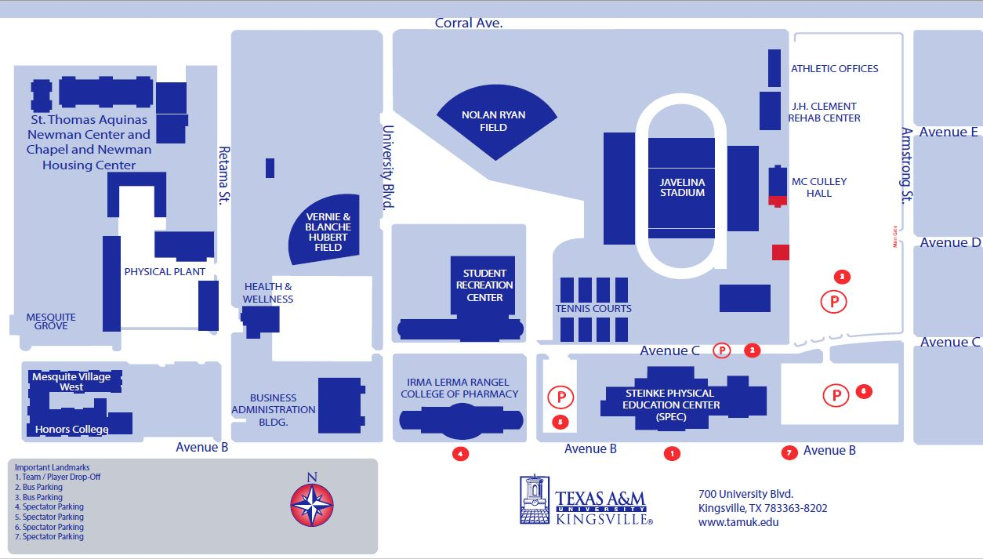

9

