2020 REGION IV

2A GOLF HANDBOOK

TO: High School Golf Coach Region IV-2A

FROM: Jane Kieschnick, Tournament Director

SUBJECT: REGION IV-2A GOLF INFORMATION

Congratulations to all teams. Enclosed is information concerning the boy’s and girl’s Region IV-2A golf tournament that will be held in Corpus Christi on April 20-23, 2020. Please make sure that you read all information carefully. There will be a mandatory Boys coaches meeting on Sunday, April 19th at 6:00pm and a Girls coaches meeting Tuesday night, April 21st at 6:00pm.

The coaches meeting will be held at the Lozano Golf Course Club House at 6:00pm on Sunday, April 19th (Boys) and Tuesday, April 21 (Girls). ALL COACHES MUST ATTEND.

The participants shall wear proper golf attire. Looking forward to meeting you.

Very Important
Region IV-2A Golf Information
Please give to appropriate person

REGION IV—CONFERENCE 2A GOLF
BOYS AND GIRLS
MONDAY, APRIL 20 - THURSDAY, APRIL 23, 2020
GABE LOZANO GOLF COURSE
CORPUS CHRISTI, TEXAS

2A BOYS – Monday-Tuesday, April 20-21

2A GIRLS – Wednesday-Thursday, April 22-23

TOURNAMENT FORMAT: Progressive both days off #1 and #10 tee box, 7:30am Tee Time

Note: In case of rain, and only 18 holes are completed, the 18 holes will stand as a completed tournament.

***SEND CHECKS TO AND ENTRIES TO CCISD ATHLETICS
Note: The district form you submit is a writeable document, you should not have any trouble typing in names. Fill out and email to jane.kieschnick@ccisd.us All entries are due immediately following your district tournament.

Make checks payable to: CCISD ATHLETICS
c/o Jane Kieschnick
2805 Oso Dr.
Corpus Christi, Texas 78415

CONTACT PERSON- JANE KIESCHNICK Corpus Christi ISD
Athletic Dept.
2805 Oso Dr.
Corpus Christi, Texas 78415

Work Phone: 361-878-4880 Work Fax: 361-878-4888 Cell phone-361-533-4514
Email-jane.kieschnick@ccisd.us

GOLF PROS: Jay Monte Head, Golf Professional

Golf Professionals: Mathew Charles, Bob Sewell

General Manager: Lawrence Vera

TOURNAMENT DIRECTOR: JANE KIESCHNICK

The coaches meeting will be held at the Lozano Golf Course Club House at 6:00 PM Sunday, April 19 (Boys) and on Tuesday, April 21 (Girls). All coaches must attend.

DISTRICT DIRECTORS: Immediately upon completion of the district tournament, email or fax entries to Jane Kieschnick, jane.kieschnick@ccisd.us or fax # 361-878-4888. List each player’s full name on entry forms. No initials or nicknames. If handwritten please make sure names are legible. PLEASE PUT IN SCORE ORDER!

The cost for each female golfer on a team is $65.00. A team of 5 players will be $325.00.

The cost for each male golfer on a team is $65.00. A team of 5 players will be $325.00.

Important: Add $65.00 for each girl or boy golf medalist not on a team.

Page 2
INFORMATION FOR GABE LOZANO COURSE
- $10.50 per player for practice round to walk, or $22.50 practice round to ride on Sunday, April 19th after 12:00pm. Must be paid at time of round. No more than 5 players per school playing during the practice round. Teams will need to practice as a team. Carts may be available.
- Boys tee times for the practice round will start at 1:00pm on Sunday, April 19th. Girls tee times for the practice round will start at 1:00pm on Tuesday, April 21st.
- Tee time reservations may be made 7 days in advance by calling Gabe Lozano Golf Course at 361-826-8016. Please tell the pro shop you are with the Regional Golf Tournament.
- Lozano driving range will be open at 5:30am on all four playing days.
- Boys will play from the Forest tees; Girls will play from the Stone colored (forward) tees.
- Play the ball as it lies. There may be ground under repair, it will be marked. Make sure players take proper drops.
- At the turn, remind players not to take too much time, restroom break and water only. Do Not Hold Up Play!
- Have players pay attention to out of bound stakes.
- *9 STROKE RULE: a player may pick up their ball at any point at or prior to the 8th shot and record a “9” if it becomes apparent to the player that a score of less than 9 is highly unlikely. If a player continues to play, the player is not disqualified. The player will get only the maximum score even if the actual score exceeds the maximum. USGA Rule 21.2 a., b., c. all apply
- Must have signed scorecards. Immediately after the round have players show their coach their scorecards and then turn them in to be verified, the entire foursome together.
- Course Marshals- Will not make any rulings, they will help to keep pace of play going. If a player has a question with a ruling either have coach or course marshal call the pro shop. If no one around play a second ball all the way through and rules committee will determine ruling after nine or at end of the round.
- Pull carts may be used but players must start off using one. Only a limited number of pull carts available.
- During play the Head Coach will have free access to a golf cart. Coaches pick up key in pro shop.
- No outside food or drink will be allowed on course. Concessions are available at each course. If you would like to place an order for your team contact Lawrence Vera at 361-826-8016.
- Spectator carts will cost $25.00 each day of the tournament and must stay on cart path.
- During play, players cannot use cell phones, I pods, or any electrical device. Range finders that measure DISTANCE ONLY may be used.

Physical Address for:

Gabe Lozano Golf Course
4401 Old Brownsville Rd.
Corpus Christi, TX 78405
361-826-8016

2020 REGIONAL GOLF TOURNAMENT

Parents and friends shall stay a substantial distance from competitors during play.
Parents and interested spectators should be reminded that they are spectators and it is not their responsibility to report possible rule violations. Rules violations should be reported by the players.

COACHING
A coach may engage with the player(s) from tee to green, once on the green no coaching is to be done.

At district, regional and state competition, only one coach is allowed to coach that team/individual once play has begun that day for that team or player(s).

The intent of the one coach rule per team or individual is not to limit a coach from coaching but rather limit the amount of coaches per school.
Penalty Structure:
First Offense – Warning
Second Offense – Stroke penalty for player and loss of coaching privileges for the coach
Third Offense – Disqualification of the player for the entire tournament

PROTESTS
Any protest must be initiated by a contestant or coach representing a participating school before the tournament director finalizes scores.

SUBSTITUTION
There shall be no substitution allowed in the individual competition. Once the tournament has begun, no substitution (except for injury) shall be allowed on a team, as a team is composed of five players.

OFFICIAL RULES
The rules committee will be the golf professional and his staff. All play will be by U.S.G.A and UIL rules. Decisions made by the rules committee will be considered final.

CADDIES AND CARTS
Contestants may NOT use caddies or electric carts during district, regional, or state matches without approval by the UIL. (A pull cart may be used.)

TIME ORDER OF STARTING
The team or individuals shall start at the time and in the order arranged by the committee. The penalty for breach of the rule is disqualification.

TIES
The lowest four scores compose the team score each day. In case of a tie, all five players will be involved in a playoff.

CELL PHONES/RADIOS
Cell phones, radios, I-pods, mp3s and any type of headphone are not permitted for players during competition. Any type of watch that can receive a text message or has access to the internet cannot be used. The first offense is a warning and the second offense is disqualification.

ELECTRONIC EQUIPMENT
Range finders are the ONLY electronic equipment allowed at the district, regional and state tournaments. Range finders that measure DISTANCE ONLY may be used during competitive rounds. The operative word is “only”. Range finders that offer functions in addition to distance measurement are illegal, even if a player disables other functions. A player using such a device in competition rounds will be subject to the UIL penalty structure (1st offense-warning; 2nd offense-disqualification).

2A Boys Regional
Golf Tournament

Lozano Golf Center – April 20th – 23rd, 2020

- USGA and UIL rules will apply at all times.
- Play will be from the forest tee markers for boys and stone tees for girls.
- The “one ball rule” shall be in effect. A player must play the same ball through the hole, not changing for a putting ball.
- Players will play the ball as it lies.
- The 14 club limit is in effect.
- ADVISE: ONLY COACHES may talk to players. Spectators CANNOT talk to players or help with rulings, they may however help look for lost balls. All spectators must remain a minimum of 40 feet from all players. They should remain on the cart paths.
a) 1st offense – Warning
  - 2nd offense – TWO shot penalty for player involved
  - 3rd offense - DISQUALIFICATION
- Ground under repair: Defined by white lined areas marked GUR. Also, any machinery tracks/ruts or ant beds to be played as GUR.
- Out of Bounds: Defined by inside edge at ground level of white stakes (#6 & #12) or any perimeter fences (#13,14, & 18). If a ball is thought to be lost or O.B. please announce & play a provisional ball. Penalty is stroke and distance.
- Penalty areas: Defined by yellow lines (#3, #12, & #16). All other penalty areas are lateral and defined by red lines / stakes. Note: Native areas of tall grass 6-12” or more in height, to be played as lateral hazards, whether marked or not.
- Immovable Obstructions: All cart paths, tee signs, service roads, restrooms, drinking fountains, sprinkler heads, flush mounted storm drains, and valve covers are immovable obstructions. You may take relief from any obstruction, if they interfere with your stance or swing, you may take free relief by dropping one club length no closer to the hole. The “nearest point of relief” always shall apply.
- You may move your ball away from “active” ant beds without penalty. Drop your ball within one club length, no closer to the hole.
- Immediately after round, turn in your signed & attested scorecard at the scorer’s table. All members of the group must be present.
- If there are any questions on a ruling, play two balls and check with the rules committee before signing your scorecard. Golf rules committee comprised of: Jay Monte- Head Golf Professional, , Bob Sewell, & Mat Charles- Golf Professionals
- Course Marshals will be driving around and checking the pace of play in all groups. Keep up with the group in front of you.
- Club throwing, violent temper display, abusive language and/or damage to the golf course or facilities are grounds for immediate disqualification.
- Distance markers: 150 yard pole on each hole (except par 3’s); distance stones every 25 yards in fairway.
- If in doubt as to procedure concerning the rules of golf, play two balls keeping both scores and check with the rules committee following play before signing scorecard.
- Hole #11 & 17, ditch and native area to the right is played as a lateral hazard thus you may not ground your club. Drop would be at point of entry.
- Earth cracks, some on the course, you may take free relief by dropping one club length no closer to the hole. You must get someone from the group to ok the move.
- Relief for an embedded ball in its own pitch mark is allowed through the green.
- Any bare area in the fairway only is considered ground under repair.
- *9 STROKE RULE: a player may pick up their ball at any point at or prior to the 8th shot and record a “9” if it becomes apparent to the player that a score of less than 9 is highly unlikely. If a player continues to play, the player is not disqualified. The player will get only the maximum score even if the actual score exceeds the maximum. USGA Rule 21.2 a.,b., c.
- Team ties will be broken by sudden death with all 5 players playing, counting the four best, starting on hole #1 and moving forward (if necessary).
- Individual ties will be broken by sudden death starting on hole #1 moving forward (if necessary).

SLOW PLAY

The following conditions and policies shall govern regulation of the pace of play by the Rules Committee:

- Each player is responsible for playing without undue delay.

- Each player is responsible for his/her group’s maintaining proper position on the course in relation to the rest of the field. Each group should be approximately a starting interval behind the preceding group throughout the whole round. The position of the group following has no bearing in determining whether or not a player’s pace of play is satisfactory. A group is deemed to be out of position if they fall a hole behind.

- A group which is out of position for as many as three holes during one round, not necessarily in consecutive order, will be considered in violation of rule 6-7 (undue Delay). Players contributing to the delay will be automatically penalized.

- Once a player is at his/her ball and it is his/her turn to play, if he walks ahead of the ball to check the position of the hole or to walk yardage, the player will be penalized for undue delay if he/she had previously been warned during the round for slow play.

- Penalties may be assessed without a player having been given prior warning during the round by a Rules Official. It is the responsibility of each player to be aware of his/her position on the golf course.

- If a group’s pace of play warrants a penalty being assessed, only players who contributed to slow play will be penalized, not necessarily every member of the group.

- Officials will use discretion concerning the pace of play of early groups. The first players will be expected to play at a reasonably fast pace. However, the groups immediately following may not be expected to maintain position behind an exceptionally fast group.

UIL GOLF DISQUALIFICATIONS

Subchapter C. Section 1260 UIL Constitution and Contest Rules
(8) Disqualifications: A player disqualified (for other than an unsportsmanlike conduct Violation) shall have the disqualification apply only to the 18-hole round in which the Infraction occurred.
- For example, a contestant disqualified (for a violation that is not unsportsmanlike) during the first or second 18-holes will not have his/her score used for the team score in the 18-hole round in which the violation occurred.
- A contestant disqualified for unsportsmanlike conduct during the first 18-holes, will not be allowed to continue. Scores from the first 18-hole round of a contestant disqualified during the second 18-holes will also be cancelled. Neither the first day 18-hole score nor the second day 18-hole score may be used for the individual or team score.

Please note that in accordance with Rule 6-8 of the USGA Golf rules, a player that must discontinue play due to illness or injury may not be subject to disqualification if the Rules committee is notified and the reason, such as illness, is considered satisfactory to the Committee. A student, who discontinues play but is not disqualified the first day, may be allowed by the Committee to return and play 18 holes on the second day. The score of the second day, in this instance, may be counted for team honors.

Inclement Weather Plan
Inclement weather, thunderstorms, and lightning can present dangerous situations for our student athletes and spectators when practicing or competing outdoors. Please be informed of the following regulations that will be followed during our regional golf tournament:
• Every effort will be made to complete all rounds as scheduled. Please be prepared to adjust accordingly and be respectful of decisions made with everyone’s safety in mind.
• The WeatherBug app will be used to determine the distance lightning. When lightning is within an 8-mile radius, all outside activities will be suspended. Once activity has been suspended, we will wait at least 30 minutes following the last sound of thunder or lightning prior to resuming activity and returning outdoors. When activity is suspended, athletes and spectators will be informed to seek shelter.
• If rounds cannot be completed due to inclement weather, the Tournament Director, will determine next
course of action.
• Please be reminded – that every effort will be made to play all rounds as scheduled, but everyone’s safety will be our top priority.
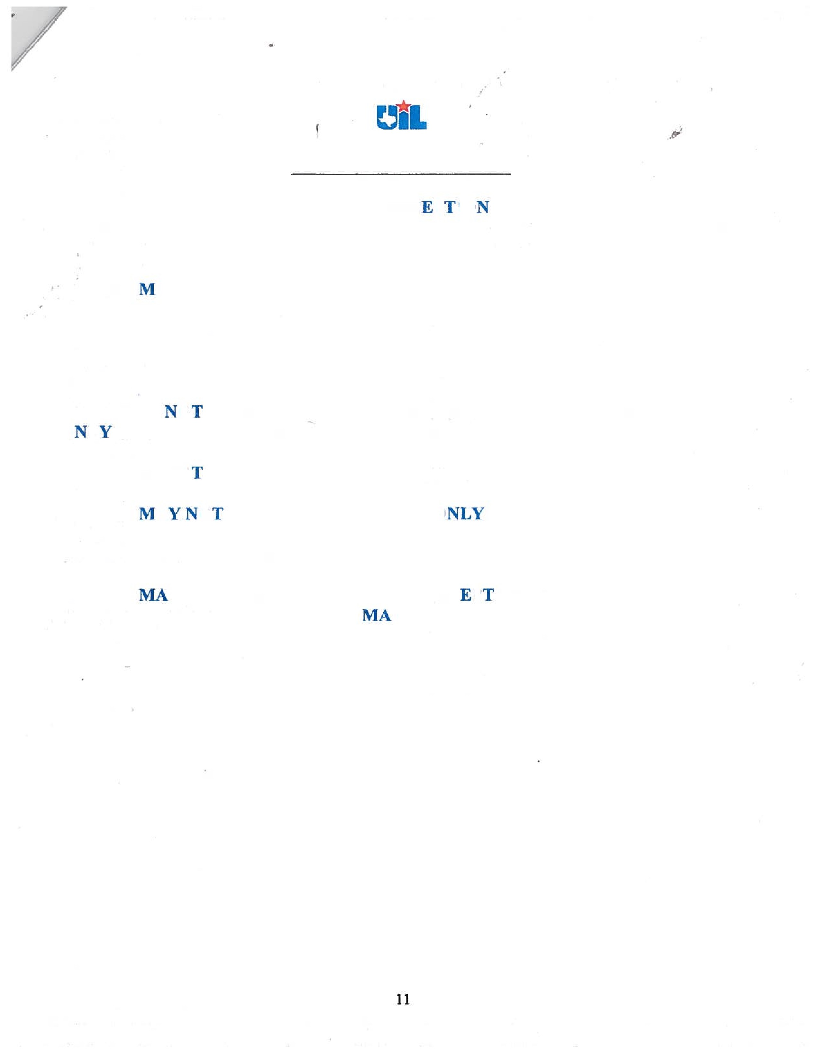
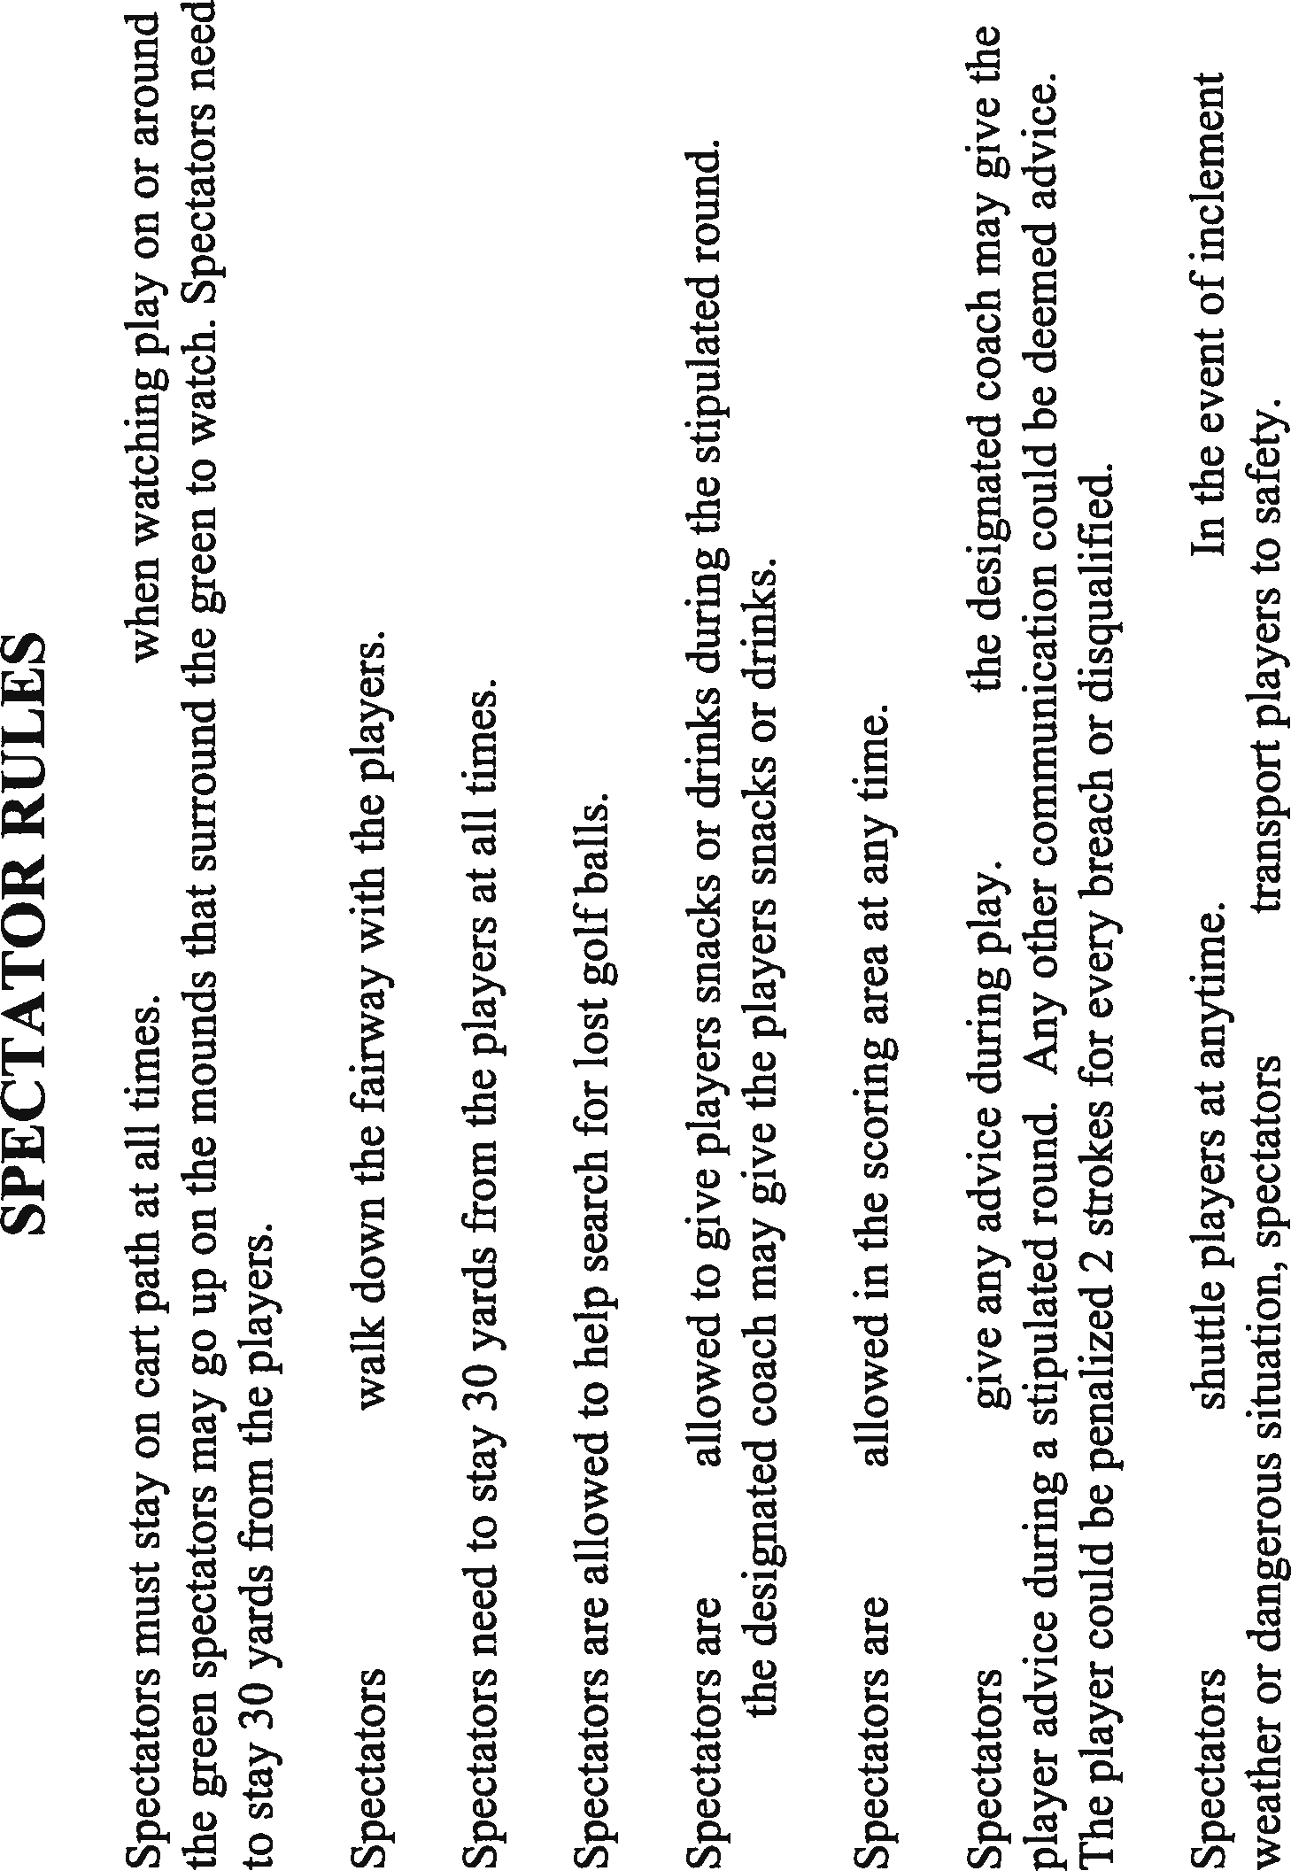

HOTELS IN CORPUS CHRISTI

Emerald Beach Hotel 1102 S. Shoreline Blvd.
Corpus Christi, TX 78401
361-883-5731
Debi Tomberlin

Holiday Inn Downtown Marina 707 N. Shoreline Blvd.
Corpus Christi, TX 78401
361-882-1700
Nicole Bankhead
Embassy Suites
4337 SPID
Corpus Christi, TX 78411
361-853-7899
Clarissa Benavides
Holiday Inn Express 5213 Oakhurst Dr.
Corpus Christi, TX 78411
361-857-7772
Staybridge Suites 5201 Oakhurst Dr.
Corpus Christi, TX 78411
361-857-7766
Comfort Suites near TAMUCC 1814 Ennis Joslin Blvd.
Corpus Christi, TX 78412
361-991-7100 John Garcia
Holiday Inn Airport 5549 Leopard St.
Corpus Christi, TX 78408
361-289-5100
Plaza Inn 2021 N. Padre Island Dr.
Corpus Christi, TX 78408 361-289-8200

Fairfield Inn by Marriott
5217 Blanche Moore Dr.
Corpus Christi, TX 78411
361-985-8393

Country Inn and Suites by Marriott 5209 Blanche Moore Dr.
Corpus Christi, TX 78411 361-985-8395
Best Westen Grand Marina 300 N. Shoreline Blvd.
Corpus Christi, TX 78401 361-883-5111
Hyatt Place
6773 SPID
Corpus Christi, TX 78412 361-985-8888
Homewood Suites
5201 Crosstown/SH 286
Corpus Christi, TX 78417 361-854-1331
Hilton Garden Inn
6117 SPID
Corpus Christi, TX 78412 361-991-8200
Hawthorne Suites by Wyndham
1442 SPID
Corpus Christi, TX 78416 361-854-3400
Courtyard by Marriott
5133 Flynn Parkway
Corpus Christi, TX 78411
361-808-8400

